Design - Class Diagrams

A report describing the Class Diagrams for the Network Appliance Service Utilisation Framework

Version: 0.1

By

Paul Fergus

Supervised by

Dr. Martin Hanneghan and Prof. Madjid Merabti

Networked Appliances Lab
School of Computing and Mathematical Sciences
Liverpool John Moores University

Table of Contents
Table of Contents ii
Table of Figures x
1 Introduction 2
1.1 Sections 2
1.2 Release Information 2
1.3 Reader Level 2
1.4 The Specification Process 3
1.5 Version Information 3
1.6 Referenced Documents 3
2 The Unified Modelling Language – Class Diagrams Overview 4
2.1 Class Diagrams 4
2.2 Classes 5
2.3 Interfaces 5
2.4 Collaborations 5
2.5 Relationships 5
2.5.1 Dependencies 5
2.5.2 Generalisation 6
2.5.3 Association 6
2.5.4 Aggregation 6
2.5.5 Composition 6
3 Class Diagram: Distributed Semantic Unstructured Services (DiSUS) Manager 8
3.1 Description 8
3.2 Issues 8
3.3 Requirements 8
3.4 Assumptions 8
3.5 Attributes 9
3.6 Methods 9
3.7 Extensions 10
4 Class Diagram: Peer Service 11
4.1 Description 11
4.2 Issues 11
4.3 Requirements 11
4.4 Assumptions 11
4.5 Attributes 11
4.6 Methods 12
4.7 Extensions 12
5 Class Diagram: P2P Implementation 13
5.1 Description 13
5.2 Issues 13
5.3 Requirements 13
5.4 Assumptions 13
5.5 Attributes 13
5.6 Methods 14
5.7 Extensions 14
6 Class Diagram: Discovery Service 15
6.1 Description 15
6.2 Issues 15
6.3 Requirements 15
6.4 Assumptions 15
6.5 Attributes 15
6.6 Methods 15
6.7 Extensions 16
7 Class Diagram: Discovery Event 17
7.1 Description 17
7.2 Issues 17
7.3 Requirements 17
7.4 Assumptions 17
7.5 Attributes 17
7.6 Methods 18
7.7 Extensions 18
8 Class Diagram: Endpoint 19
8.1 Description 19
8.2 Issues 19
8.3 Requirements 19
8.4 Assumptions 19
8.5 Attributes 19
8.6 Methods 19
8.7 Extensions 20
9 Class Diagram: Input Endpoint Message Listener 21
9.1 Description 21
9.2 Issues 21
9.3 Requirements 21
9.4 Assumptions 21
9.5 Attributes 21
9.6 Methods 21
9.7 Extensions 22
10 Class Diagram: Service Implementation Manager 23
10.1 Description 23
10.2 Issues 23
10.3 Requirements 23
10.4 Assumptions 23
10.5 Attributes 23
10.6 Methods 24
10.7 Extensions 24
11 Class Diagram: Peer Service Manager 25
11.1 Description 25
11.2 Issues 25
11.3 Requirements 25
11.4 Assumptions 25
11.5 Attributes 25
11.6 Methods 25
11.7 Extensions 25
12 Class Diagram: Peer Service Advertisement 26
12.1 Description 26
12.2 Issues 26
12.3 Requirements 26
12.4 Assumptions 26
12.5 Attributes 26
12.6 Methods 27
12.7 Extensions 28
13 Class Diagram: Service Class Advertisement 29
13.1 Description 29
13.2 Issues 29
13.3 Requirements 29
13.4 Assumptions 29
13.5 Attributes 29
13.6 Methods 29
13.7 Extensions 30
14 Class Diagram: Service Specification Advertisement 31
14.1 Description 31
14.2 Issues 31
14.3 Requirements 31
14.4 Assumptions 31
14.5 Attributes 31
14.6 Methods 32
14.7 Extensions 34
15 Class Diagram: Service Implementation Advertisement 35
15.1 Description 35
15.2 Issues 35
15.3 Requirements 35
15.4 Assumptions 35
15.5 Attributes 36
15.6 Methods 36
15.7 Extensions 37
16 Class Diagram: Service Ontology Model 38
16.1 Description 38
16.2 Issues 38
16.3 Requirements 38
16.4 Assumptions 38
16.5 Attributes 38
16.6 Methods 39
16.7 Extensions 39
17 Class Diagram: Service Model 40
17.1 Description 40
17.2 Issues 40
17.3 Requirements 40
17.4 Assumptions 40
17.5 Attributes 40
17.6 Methods 40
17.7 Extensions 41
18 Class Diagram: Service Profile Model 42
18.1 Description 42
18.2 Issues 42
18.3 Requirements 42
18.4 Assumptions 42
18.5 Attributes 43
18.6 Methods 43
18.7 Extensions 44
19 Class Diagram: Service Process Model 45
19.1 Description 45
19.2 Issues 45
19.3 Requirements 45
19.4 Assumptions 45
19.5 Attributes 45
19.6 Methods 45
19.7 Extensions 46
20 Class Diagram: Atomic Process 47
20.1 Description 47
20.2 Issues 47
20.3 Requirements 47
20.4 Assumptions 47
20.5 Attributes 47
20.6 Methods 48
20.7 Extensions 49
21 Class Diagram: Parameter 50
21.1 Description 50
21.2 Issues 50
21.3 Requirements 50
21.4 Assumptions 50
21.5 Attributes 50
21.6 Methods 51
21.7 Extensions 52
22 Class Diagram: The Service Grounding Model 53
22.1 Description 53
22.2 Issues 53
22.3 Requirements 53
22.4 Assumptions 53
22.5 Attributes 53
22.6 Methods 53
22.7 Extensions 54
23 Class Diagram: Atomic Process Grounding 55
23.1 Description 55
23.2 Issues 55
23.3 Requirements 55
23.4 Assumptions 55
23.5 Attributes 55
23.6 Methods 56
23.7 Extensions 58
24 Class Diagram: Service Input/Output Parameter 59
24.1 Description 59
24.2 Issues 59
24.3 Requirements 59
24.4 Assumptions 59
24.5 Attributes 59
24.6 Methods 60
24.7 Extensions 61
25 Class Diagram: Service Interface Model 62
25.1 Description 62
25.2 Issues 62
25.3 Requirements 62
25.4 Assumptions 63
25.5 Attributes 63
25.6 Methods 63
25.7 Extensions 65
26 Class Diagram: Device Capability Advertisement 66
26.1 Description 66
26.2 Issues 66
26.3 Requirements 66
26.4 Assumptions 66
26.5 Attributes 66
26.6 Methods 67
26.7 Extensions 68
27 Class Diagram: Context Template Manager 69
27.1 Description 69
27.2 Issues 69
27.3 Requirements 69
27.4 Assumptions 69
27.5 Attributes 70
27.6 Methods 70
27.7 Extensions 71
28 Class Diagram: Distributed Emergent Semantics (DistrES) Service 72
28.1 Description 72
28.2 Issues 72
28.3 Requirements 72
28.4 Assumptions 73
28.5 Attributes 73
28.6 Methods 73
28.7 Extensions 74
29 Class Diagram: Extraction Engine Service 75
29.1 Description 75
29.2 Issues 75
29.3 Requirements 75
29.4 Assumptions 75
29.5 Attributes 75
29.6 Methods 75
29.7 Extensions 76
30 Class Diagram: Evolutionary Pattern Extraction Engine Service 77
30.1 Description 77
30.2 Issues 77
30.3 Requirements 77
30.4 Assumptions 77
30.5 Attributes 77
30.6 Methods 77
30.7 Extensions 78
31 Class Diagram: DistrES Ontology 79
31.1 Description 79
31.2 Issues 79
31.3 Requirements 79
31.4 Assumptions 79
31.5 Attributes 79
31.6 Methods 80
31.7 Extensions 81
32 Class Diagram: Semantic Interoperability and Signature Matching (SISM) Service 82
32.1 Description 82
32.2 Issues 82
32.3 Requirements 82
32.4 Assumptions 82
32.5 Attributes 82
32.6 Methods 83
32.7 Extensions 83
33 Class Diagram: Abstract Matcher Service 84
33.1 Description 84
33.2 Issues 84
33.3 Requirements 84
33.4 Assumptions 84
33.5 Attributes 84
33.6 Methods 84
33.7 Extensions 85
34 Class Diagram: Concrete Matcher Service 86
34.1 Description 86
34.2 Issues 86
34.3 Requirements 86
34.4 Assumptions 86
34.5 Attributes 86
34.6 Methods 86
34.7 Extensions 87
35 Class Diagram: Encrypt/Decrypt Data 88
35.1 Description 88
35.2 Issues 88
35.3 Requirements 88
35.4 Assumptions 88
35.5 Attributes 88
35.6 Methods 88
35.7 Extensions 88
36 References 89

Table of Figures
Figure 1 UML Notation for a Class Diagram 4
Figure 2 Distributed Semantic Unstructured Services Manager 8
Figure 3 Peer Service 11
Figure 4 P2P Implementation Classes 13
Figure 5 Discovery Service 15
Figure 6 Discovery Event Classes 17
Figure 7 Endpoint Classes 19
Figure 8 Input Endpoint Message Listener 21
Figure 9 Service Implementation Manager 23
Figure 10 Peer Service Manager 25
Figure 11 Peer Service Advertisement Classes 26
Figure 12 Service Class Advertisement Classes 29
Figure 13 Service Specification Advertisement Classes 31
Figure 14 Service Implementation Advertisement Classes 35
Figure 15 Service Ontology Model 38
Figure 16 Service Model 40
Figure 17 Service Profile Model 42
Figure 18 Service Process Model 45
Figure 19 Atomic Process 47
Figure 20 Parameter 50
Figure 21 Service Grounding Model 53
Figure 22 Atomic Process Grounding 55
Figure 23 Service Input/Output Parameter 59
Figure 24 Service Interface Model 62
Figure 25 Device Capability Advertisement 66
Figure 26 Context Template Manager 69
Figure 27 Distributed Emergent Semantics Service 72
Figure 28 Extraction Engine Service 75
Figure 29 Evolutionary Pattern Extraction Engine Service 77
Figure 30 DistrES Ontology 79
Figure 31 Semantic Interoperability and Signature Matching Service 82
Figure 32 Abstract Matcher Service 84
Figure 33 Concrete Matcher Service 86
Figure 34 Encrypt/Decrypt Data 88

ABSTRACT
User demands and technological advances are driving the complex integration between heterogeneous devices, and moving us closer to pervasive and ubiquitous computing environments. The home of the future will include an embedded ‘intelligence’ and accommodate a flexible integration of services to perform functions that are only limited by our imagination. The family car and working environment will be closely integrated allowing the children to watch a movie on digital screens embedded in the back of the driver and passenger seats, by directly streaming the digital content from the DVD player located in the living room of your home. Furthermore you will be able to access and listen to music stored on your MP3 player, which you accordingly left at the office on Friday night, via your wireless enabled headphones, without interrupting the children’s viewing experience. This vision will expose the functionalities offered by devices as independent services [1] and capitalise on advances made in global communications to revolutionise the way we interact with the plethora of devices that surround us.
This vision will require us to perceive and interact with our devices in ways we have never experienced before. The constraints placed on us by manufacturers and service providers will become a thing of the past as the flexible and seamless integration of distributed devices become common place. One of the challenges is to expose the functions offered by devices as services. Manufactures will need to re-engineer most common household appliances and produce solutions that better utilise the functionalities a particular device offers. A framework needs to be developed that allows services to be described using machine-processible semantics enabling devices to make informed decisions regarding the composition process once a potential service has been discovered. The framework needs to utilise advances made in Peer-to-Peer technologies and provide discovery mechanisms that ensure collaborations between devices encompass vocabularies that support machine-level understanding.
In this report we describe how we have designed the Networked Appliance Service Utilisation Framework (NASUF) including the Distributed Semantic Unstructured Services (DiSUS) [2] protocol, the Distributed Emergent Semantics (DistrES) algorithm [3] and the Semantic Interoperability and Signature Matching (SISM) algorithms [4]. We explain how NASUF implements the DiSUS protocol to publish and discover unstructured services within P2P networks, the DistrES algorithm to manage and evolve ontological information over time based on general consensus, and the SISM algorithm to dynamically compose services and resolve terminology differences that occur.

Introduction
The Network Appliance Service Utilisation Framework (NASUF) is designed to allow service-enabled devices to be seamlessly integrated within Peer-to-Peer (P2P) networks. Once these devices have been deployed they can expose the functions they provide as independent services, which are described and discovered using machine-processable semantics.
The framework is flexible and does not place any constraints on the underlying technologies used. It is designed to provide a set of core interfaces that must be implemented in order to enable services to be effectively described and discovered within P2P networks. This framework does not place any constraints on the underlying communication protocols used or the P2P technology used to deploy devices and the services they provide. Furthermore it does not place any constraints on the service technology used allowing a plethora of different services to be used and integrated with relative ease.
This is the first release of this specification and is still a work in progress. Its primary goal is to define a set of generic interfaces that support the above mentioned requirements.

Sections
This document is split into two sections. The first section provides a conceptual overview of UML [5] and Class Diagram modelling within UML. It describes the vocabulary used and provides some simple illustrations that show a simple Class Diagram. The second section provides a detailed list of all the Class Diagrams used to define this framework.

Release Information
This document is a work in progress and is an initial first draft. This release is an unstable release that is designed to prompt discussions in order to refine our overall framework design. Its primary function is to highlight the functionalities this framework provides and to prompt further investigation.

Reader Level
This document can be used by a number of readers, who are concerned with the framework from a number of different viewpoints.
- Service Developers
- Distributed Computing Developers
- Semantic Web Developers
- Networked Appliance Developers
- Framework Designers
- Enterprise Architects
This specification assumes that the reader is converse with UML and more specifically Class Diagram design. The specification is language and protocol agnostic and could be used to implement service-enabled networked appliances using a number of different languages, which implement a number of different communication protocols.

The Specification Process
The specification process is performed as part of a PhD project, with a number of researchers and Academic staff involved in its creation. The specification is reviewed subject matter experts within the fields of UML modelling, P2P technologies, Semantic Web technologies and Networked Appliances. We hope that as this specification evolves it will be opened up to a much wider audience, whereby contributions can be made by a number of expert groups.
The current process involves the framework design using a number of UML models. At predetermined millstones the designs are submitted to the subject matter experts, which are then evaluated. Any changes are performed and all design decisions are challenged. This process continues until defined work packages are completed.

Version Information
This version is not designed to be used for implementations. This version is designed to prompt discussion on this framework design to ensure that the framework captures all the required functionality.

Referenced Documents
The following documents should be read in conjunction with this Class Diagram document.
- NASUF – Use Case Diagram 1.0.doc
- NASUF – Activity Diagram 1.0.doc
- NASUF – Sequence Diagram 1.0.doc

The Unified Modelling Language – Class Diagrams Overview
This document defines all the Class Diagrams that exist within the NASUF framework. As a result this section only concerns itself with Class Diagram modelling. Other UML models are discussed in relevant documents that should be read in conjunction with this document as detailed in Section 1.6 above.

Class Diagrams
If you look around your immediate environment, you will see a number of “Things”. These things will have a number of attributes (properties) and a number of behaviours (operations). You will also be able to deduce that these “Things” belong to certain categories. For example the chair you are sitting on belongs to the “Furniture” category and the person sat next to you belongs to the “Human Being” category. In object oriented programming we refer to these categories as classes. A class can be viewed as a group of things that have similar attributes and posses similar behaviours. For example a class of dog has a tail (attribute) and it barks (behaviour). A class in UML is represented as a square, which contains the class name, its associated properties and the behaviours it has.

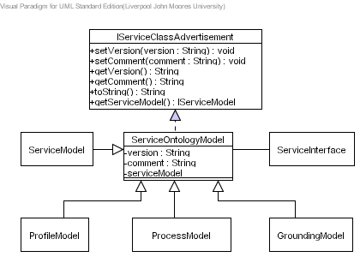
Figure 1 UML Notation for a Class Diagram
The class itself is split into three sections; the top area contains the name of the class, the middle contains the attributes and the bottom contains the operations supported by the class.
It is important that we think about classes of things and the attributes and operations they support because it is easier to simulate a complex real-world environment when we represent classes as real-world things. Furthermore classes help the analyst by allowing them to talk to clients using terminology they understand, which stimulates the client to reveal important details about the problems they want to solve.

Classes
The name of a class is by convention, a word with its first letter capitalised. As illustrated in Figure 1, it appears near the top of the rectangle. If your class has a two-word name, join the two words together and capitalise the first letter of each word, for example ServiceOntologyModel.

Interfaces
After you’ve created a number of classes, you might notice they’re not related to a particular parent, but their behaviours might include some of the same operations with the same signatures (parameters you pass to the operation). You can code the operations for one of the classes and reuse them in the others. Another possibility is that you develop a set of operations for classes in one system, and reuse them for classes in another. Either way you will want to capture the reusable set of operations. The interface is the UML construct that enables you to do this. An interface is a set of operations that specifies something about a class’s behaviour. Think of an interface as a class that only has operations - no attributes. The interface is a set of operations that a class presents to other classes.
Instead of using a new element to represent an interface, you can use a class icon with <<Interface>> situated just above the class name.

Collaborations
To identify the collaborations, we need to study the responsibilities of a class and determine what other classes the object interacts with. In short, what other classes does this object need to perform all its required responsibilities and complete its job? As you examine the collaborations, you might find that you have missed some necessary classes or that some classes that you initially identified are not needed. To help discover collaborations Use Case scenarios can be used. For each Use Case, identify the objects and the messages that they exchange. You may want to create collaboration diagrams to document this step.
Obviously there can be an infinite number of scenarios. The purpose of this part of the process is not to document all possible scenarios, which is obviously an impossible task. The real purpose of creating Use Case scenarios is to help you define the choice of your classes and their responsibilities. By examining the collaborations you might identify an important class that you missed.

Relationships

Dependencies
A dependency is a type of relationship, whereby one class uses another class. The most common usage of a dependency is to show that the signature of one class’s operation uses another class. Suppose you are designing a system that displays corporate forms onscreen, so employees can fill them out. The employee uses a menu to select the form to fill out. In your design, you have a System class and a Form class. Among its many operations, the System class has displayForm(f:Form). The form the system displays obviously depends on which form the user selects. The UML notation for this is a dotted line with an arrow head.

Generalisation
One of the interesting features of object oriented design is the close relationship with the common-sense aspects of day-to-day life: For example if you know something about an appliance then you know that it has an on and off switch or button. Furthermore it has a brand name and a unique serial number. Another example may be a family pet such as a cat. You know that it meows, catches birds and plays with mice. You also know that it is a mammal, it sleeps, it is mobile and it has to eat at various times of the day.
A lot of these properties are generic to a lot of animals. For example a dog and a monkey are also mammals – they also sleep and move from one location to anther (mobile). Moving more generic features to super classes provides generalised features to be inherited by more specific objects in a typical classification tree. Object-orientation refers to this as inheritance. In UML this is referred to as generalisation. This means that one class (the child class or a subclass) can inherit attributes and operations from anther class (known as the parent class or a superclass). The parent class is a more general class than its child class.

Association
Objects do not exist in isolation but rather they have relationships with other objects. Objects that are conceptually connected to each other in this way are called associations. For example, when you turn on your television, a relationship exists between you and the television. When you turn the television on you have a unidirectional (one-way) association with the television.
Other associations exist which are bidirectional, for example when you marry someone you have an association called “is married to” which can be used in either direction between two objects, i.e. John is married to Lisa and Lisa is married to John.
Associations are not just limited to unidirectional and bidirectional relationships but can also have multiple associations. An object might be associated with another object in more than one way. For example if you and a colleague at work are friends then you have a “is a friend of” association as well as a “is a co-worker of” association.

Aggregation
There are many examples of aggregation that exist within our real-world environment. For example a car consists of doors, a bonnet, a boot, wheels, a steering wheel and windows. The combination of these objects is known as an aggregation. This is another type of association between objects and in this instance, means that the car is made from a number of objects. Aggregation is purely conceptual, and does no more than to distinguish the whole from its parts. Aggregation does not change the meaning of associations. Therefore, aggregation between a component class and an aggregate class is equivalent to a general association among the involved classes.

Composition
Another type of association is called composition, which is similar to Aggregation. Both composition and aggregation are used for modelling a “whole/part” relationship in which one class represents the “whole” that consists of smaller things (the “parts”). Composition has a stronger meaning than aggregation. Composition is a form of aggregation where the lifetime of the parts depends on the lifetime of the whole (i.e. the parts may be created after the whole, and can also be explicitly removed before the whole, however, if the whole is destroyed, then the parts die with it). Because of that, the multiplicity of a composite end, (unlike an aggregate end), must always be at the most one (i.e., it cannot be shared by different instances of the owner class).

Class Diagram: Distributed Semantic Unstructured Services (DiSUS) Manager

Description
This Class Diagram illustrates the classes used to implement distributed semantic unstructured services within this framework. The Class Diagram is illustrated in Figure 2.
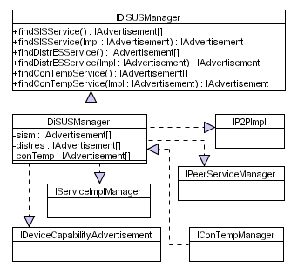
Figure 2 Distributed Semantic Unstructured Services Manager

Issues
The issues associated with the Class Diagram are not known at this stage.

Requirements
The DiSUSManager class must form part of the bootstrap software that allows the device to discover and bind to all the core services required within this framework. The DiSUSManager class must implement the IDiSUSManager, the IP2PImpl, the IPeerServiceManager, the IDeviceCapabilityAdvertisement, the IConTempService, and the IServiceImplManager interfaces. The IDiSUSManager interface provides a set of methods that allows the device to discover all the core services required within this framework. The IP2PImpl provides a set of methods that allows the device to discover the required P2P services and join the P2P network. The IPeerServiceManager allows the device to create and publish all the core and application specific peer services provided by the device. The IServiceImplManager interface allows the service container to be started and implementation services to be published within the service container – this is dependant on the service technology being used. The IDeviceCapabilityAdvertisement interface allows the device capabilities to be created and published locally and remotely within the P2P network. All these interfaces and the methods they provide must be implemented – the code details within each method are left to the device manufacturer.

Assumptions
The assumptions for this Class Diagram are not known at this stage of the design.

Attributes
This Class Diagram supports several classes with each class containing zero or more attributes. Each of these attributes are listed and described below.
Class | Attribute | Description
DiSUSManager | sism | There will be several SISM services within the P2P network, which will be provided by other devices connected to the network, consequently a service request will result in several advertisements being returned. This attribute will contain all the service advertisements returned. This collection allows alternative services to be used in the advent of a particular service within the collection becoming unavailable.
DiSUSManager | distres | There will be several DistrES services within the P2P network, which will be provided by other devices connected to the network, consequently a service request will result in several advertisements being returned. This attribute will contain all the service advertisements returned. This collection allows alternative services to be used in the advent of a particular service within the collection becoming unavailable.
DiSUSManager | conTemp | There will be several ConTemp services within the P2P network, which will be provided by other devices connected to the network, consequently a service request will result in several advertisements being returned. This attribute will contain all the service advertisements returned. This collection allows alternative services to be used in the advent of a particular service within the collection becoming unavailable.
Table 1 DiSUS Attributes

Methods
This Class Diagram supports several classes with each class containing zero or more methods. Each of these methods are listed and described below.
Class | Method | Description
DiSUSManager | findSISMManager | This method propagates a service request for SISM Services. After some pre-determined time this method returns a collection of IAdvertisments for each service discovered. This collection of advertisements is added to the sism attribute.
DiSUSManager | findDistrESManager | This method propagates a service request for DistrES Services. After some pre-determined time this method returns a collection of IAdvertisments for each service discovered. This collection of advertisements is added to the distres attribute.
DiSUSManager | findConTempService | This method propagates a service request for ConTemp Services. After some pre-determined time this method returns a collection of IAdvertisments for each service discovered. This collection of advertisements is added to the conTemp attribute.
Table 2 DiSUS Methods

Extensions
There are no known extensions for this Class Diagram at this stage of the design.

Class Diagram: Peer Service

Description
This Class Diagram illustrates the required Peer Service class, including its associated subclasses which must be used within this framework. The Class Diagram is illustrated in Figure 3.
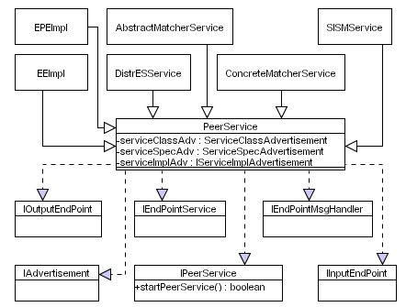
Figure 3 Peer Service

Issues
The issues associated with the Class Diagram are not known at this stage.

Requirements
This is a service oriented middleware, which consists of several core services and zero or more application specific services. All these services are peer services. The peer service class has several subclassed services that implement the core functionality within the framework. The peer service must implement several interfaces in order to allow each peer service to expose the functionality the peer service provides using an end point address. The peer service and its associated subclasses must allow devices to explicitly implement the core functionality required within this framework. It is not mandatory that the device explicitly implements all the core peer services, however unimplemented peer services will have to be discovered and used remotely within the P2P network.

Assumptions
Each peer service has three service advertisements – the information to create these advertisements must be passed as a parameter to the peer service constructor.

Attributes
This Class Diagram supports several classes with each class containing zero or more attributes. Each of these attributes are listed and described below.
Class | Attribute | Description
PeerService | serviceClassAdv | This attribute contains the service class advertisement for the peer service – only one service class advertisement per peer service is allowed.
PeerService | serviceSpecAdv | This attribute contains the service specification advertisements for each peer service – only one service specification advertisement per peer service is allowed.
PeerService | serviceImplAdv | This attribute contains the service implementation advertisement for each peer – only one service implementation advertisement per peer service is allowed.
Table 3 Peer Service Attributes

Methods
This Class Diagram supports several classes with each class containing zero or more methods. Each of these methods are listed and described below.
Class | Method | Description
IPeerService | startPeerService | This method allows the peer service to be started. In this instance the endpoint used by the peer service will be started allowing the service to receive messages from within the P2P network. Once a service has been created and the service advertisements have been created and published, the peer service must be started.
Table 4 Peer Service Methods

Extensions
This section only illustrates Peer Service and its associated subclasses, which form the main core services required in this framework. However devices may support zero or more application specific services. In this instance application specific peer services must extend the peer service class and implement the IPeerService interface.

Class Diagram: P2P Implementation

Description
This Class Diagram illustrates what the required P2P implementation classes needed within this framework. The Class Diagram is illustrated in Figure 4.
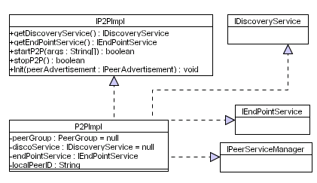
Figure 4 P2P Implementation Classes

Issues
The issues associated with the Class Diagram are not known at this stage.

Requirements
The P2P implementation class enables the device to be connected to the P2P network. It allows the device to publish the functions the device provides. It also allows the device to discover services provided by other devices within the P2P network. This class must implement the discovery service and the endpoint service. The discovery service must allow the device to propagate and receive messages within the network and the endpoint service allows the device to host the peer services it provides on the network. This class must also implement the IPeerServiceManager to create and start the peer services the device provides.

Assumptions
The assumptions for this Class Diagram are not known at this stage of the design.

Attributes
This Class Diagram supports several classes with each class containing zero or more attributes. Each of these attributes are listed and described below.
Class | Attribute | Description
P2PImpl | peerGroup | This attribute is a string that contains the name of the peer group the device belongs to. The device will use this peer group name to connect to the P2P network when it is first started.
P2PImpl | discoService | This attribute contains a binding to a particular discover service implementation used within the P2P network. This binding allows the device to receive and propagate messages within the P2P network.
P2PImpl | endPointService | This attribute contains a binding to a particular endpoint service implementation used within the P2P network. This binding allows endpoints to be created and associated with individual peer services.
P2PImpl | localPeerID | This is the peers local unique ID that uniquely identifies the device on the network.
Table 5 P2P Implementation Attributes

Methods
This Class Diagram supports several classes with each class containing zero or more methods. Each of these methods are listed and described below.
Class | Method | Description
IP2PImpl | getDiscoveryService | This method retrieves the discovery service from the P2P implementation. The return value from this is assigned to the discoService attribute.
IP2PImpl | getEndPointService | This method retrieves the endpoint service from the P2P implementation. The return value from this is assigned to the endPointService attribute.
IP2PImpl | startP2P | This method starts the P2P implementation. It allows the device to connect to the network and authenticate itself.
IP2PImpl | stopP2P | This method stops the P2P implementation. It allows the device to disconnect itself from the network.
IP2PImpl | init | This method allows the device to perform any initialisation functions required before it joins the network.
Table 6 P2P Implementation Methods

Extensions
There are no known extensions for this Class Diagram at this stage of the design.

Class Diagram: Discovery Service

Description
This Class Diagram illustrates the classes required for the discovery service used within this framework. The Class Diagram is illustrated in Figure 5.
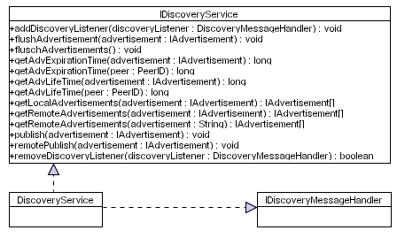
Figure 5 Discovery Service

Issues
The issues associated with the Class Diagram are not known at this stage.

Requirements
The discovery service classes must allow advertisements to be published and discovered within this framework. The discovery mechanisms must also allow the device to flush advertisements from the local cache and allow the device to query information about existing advertisements it has such as expiration and life time values. Advertisements must be published locally as well as remotely within the P2P network, conversely they must also be discovered locally and remotely. The IDiscoveryService class must implement the IDiscoveryMessageHandler, which allows asynchronous message passing between peer services.

Assumptions
The assumptions at this stage are that the Discovery Service will publish and discover advertisements within the P2P network using XML.

Attributes
This Class Diagram supports several classes with each class containing zero or more attributes. Each of these attributes are listed and described below.
Class | Attribute | Description
NA | NA | NA
Table 7 Discovery Service Attributes

Methods
This Class Diagram supports several classes with each class containing zero or more methods. Each of these methods are listed and described below.
Class | Method | Description
IDiscoveryService | addDiscoveryListener | This allows the service to register a listener for discovery responses. Discovery requests are propagated within the P2P network and all responses are processed by the registered discovery listener
IDiscoveryService | flushAdvertisements | This method allows the device to flush either a specific advertisement or all advertisements from the local cache.
IDiscoveryService | getAdvExpirationTime | This method returns the time value used to determine how long a document should be cached for. This value is not used by the device that published the advertisement but rather by remote devices within the network.
IDiscoveryService | getAdvLifeTime | This method returns the time value used to determine how long an advertisement should be kept in the local cache.
IDiscoveryService | getLocalAdvertisements | This method retrieves all the advertisements from the local cache.
IDiscoveryService | getRemoteAdvertisements | This method allows the device to discover remote advertisements within the P2P network. The device can specify how long this discovery period should be.
IDiscoveryService | publish | This method allows the device to publish advertisements locally within the devices advertisement cache.
IDiscoveryService | remotePublish | This method allows the device to publish advertisements remotely within the P2P network.
IDiscoveryService | removeDiscoveryListener | This method removes the discover listener.
Table 8 Discovery Service Methods

Extensions
There are no known extensions for this Class Diagram at this stage of the design.

Class Diagram: Discovery Event

Description
This Class Diagram illustrates the classes required to detect discovery events when advertisements are received from the P2P network. The Class Diagram is illustrated in Figure 6.
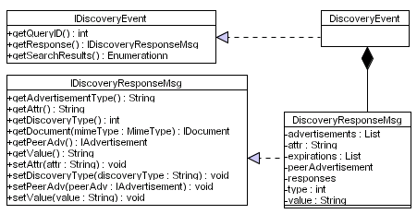
Figure 6 Discovery Event Classes

Issues
The issues associated with the Class Diagram are not known at this stage.

Requirements
The discovery event classes provide an asynchronous event listener for incoming advertisements that are received within the P2P network. These classes must allow the device to retrieve a discovery response message once an event has been triggered. The device must also be able to extract the advertisement(s) from this discovery response message. The discovery response message object must allow the device to determine what type of advertisement has been received. Advertisement queries must contain the advertisement type the peer wishes to discover along with any associated query attributes. This class must also allow the device to extract the peer advertisement

Assumptions
The assumptions for this Class Diagram are not known at this stage of the design.

Attributes
This Class Diagram supports several classes with each class containing zero or more attributes. Each of these attributes are listed and described below.
Class | Attribute | Description
DiscoveryResponseMsg | advertisements | This attribute contains a list of all the advertisements received.
DiscoveryResponseMsg | attr | This attribute contains the attribute used by the query.
DiscoveryResponseMsg | expirations | This attribute contains the expirations for the DiscoveryResponseMsg object
DiscoveryResponseMsg | peerAdvertisement | This attribute contains the responding peer’s advertisement.
DiscoveryResponseMsg | responses | This attribute contains the responses
DiscoveryResponseMsg | type | This attribute contains the type of advertisement used by the query.
DiscoveryResponseMsg | value | This attribute contains the value used by the query.
Table 9 Discovery Event Attributes

Methods
This Class Diagram supports several classes with each class containing zero or more methods. Each of these methods are listed and described below.
Class | Method | Description
IDiscoveryEvent | getQueryID | This method returns the query id associated with a particular response.
IDiscoveryEvent | getResponse | This method returns the response associated with a particular event.
IDiscoveryEvent | getSearchResults | This method returns a collection of advertisements contained in the discovery response for this event.
IDiscoveryResponseMsg | getAdvertisements | This method returns an enumeration for the response advertisement objects.
IDiscoveryResponseMsg | getAdvertisementType | This method returns the advertisement type for a particular advertisement.
IDiscoveryResponseMsg | getAttr | This method returns the attributes used by the query.
IDiscoveryResponseMsg | getDiscoveryType | This method returns a discovery type.
IDiscoveryResponseMsg | getDocument | This method converts the advertisement into an XML document.
IDiscoveryResponseMsg | getPeerAdv | This method returns the peer advertisement for the responding peer.
IDiscoveryResponseMsg | getValue | This method returns the value used by the query.
IDiscoveryResponseMsg | setAttr | This method sets the query attributes
IDiscoveryResponseMsg | setDiscoveryType | This method sets the discovery type
IDiscoveryResponseMsg | setPeerAdv | This method sets the peer advertisement.
IDiscoveryResponseMsg | setValue | This method sets the query value.
Table 10 Discovery Event Methods

Extensions
There are no known extensions for this Class Diagram at this stage of the design.

Class Diagram: Endpoint

Description
This Class Diagram illustrates the classes required for the Endpoints used within this framework. The Class Diagram is illustrated in Figure 7.
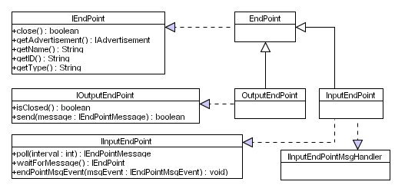
Figure 7 Endpoint Classes

Issues
The issues associated with the Class Diagram are not known at this stage.

Requirements
Within this framework devices expose the functionality they have as peer services. Each peer service requires several endpoints that allow other services within the network to connect and invoke the service. Endpoints can be thought of as TCP/IP sockets whereby a client connects to a server socket and sends data. As such each peer service must implement an input endpoint – the endpoint must either poll for incoming messages, wait (synchronous method invocation), or register an input message handler (Asynchronous). If peer services return a value then they must create an output endpoint using information contained in the message sent by the invoking peer. This output allows the peer service to return a value to the input endpoint the peer invoker is listening on. The combination of Input and Output EndPoint services allows peer services to perform unidirectional or bidirectional communications.

Assumptions
The assumptions for this Class Diagram are not known at this stage of the design.

Attributes
This Class Diagram supports several classes with each class containing zero or more attributes. Each of these attributes are listed and described below.
Class | Attribute | Description
N/A | N/A | N/A
Table 11 Endpoint Attributes

Methods
This Class Diagram supports several classes with each class containing zero or more methods. Each of these methods are listed and described below.
Class | Method | Description
IEndPoint | close | This method allows the EndPoint to be closed.
IEndPoint | getAdvertisement | This method allows the EndPoint advertisement to be retrieved. This is used to create a particular EndPoint.
IEndPoint | getName | This method gets the name of the EndPoint.
IEndPoint | getID | This method returns the unique Endpoint ID.
IEndPoint | getType | This method returns the type of EndPoint being used.
IOutputEndPoint | isClosed | This method returns a true or false value describing the state of the Endpoint – if the endpoint is closed a value of true is returned.
IOutputEndPoint | send | This method allows the device to send messages to the service EndPoint.
IInputEndPoint | poll | This method allows a peer service to periodically poll for messages received via the Input EndPoint. The poll interval used can be defined. This is an alternative way to Synchronous method calling.
IInputEndPoint | waitForMessage | This method allows the peer service to wait for incoming messages received via the Input EndPoint. This is a Synchronous method call.
IInputEndPoint | endPointMsgEvent | This method allows the peer service to register an EndPoint message listener. This mechanism allows Asynchronous method calls.
Table 12 Endpoint Methods

Extensions
There are no known extensions for this Class Diagram at this stage of the design.

Class Diagram: Input Endpoint Message Listener

Description
This Class Diagram illustrates the classes required for implementing input endpoint message listeners within this framework. The Class Diagram is illustrated in Figure 8.
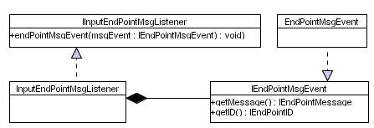
Figure 8 Input Endpoint Message Listener

Issues
The issues associated with the Class Diagram are not known at this stage.

Requirements
There will be occasions when you do not want to block peer service communication as is the case of Synchronous method calls. Therefore input EndPoints must have the ability to add event listeners that inform the service when a message is received – this is known as Asynchronous method invocation. The listener must have an associated event, which when triggered allows the device to retrieve the message including the message ID.

Assumptions
The assumption at this stage is that an input message listener is the only listener required at this stage. We assume that peer services will listen for messages on an input endpoint and that device manufacturers will chose to either implement synchronous or asynchronous method calls. Peers wishing to connect to the input endpoint create an output endpoint (output → input) using the endpoint advertisement for the target input endpoint. We assume that data will be sent to the peer service using this output endpoint and if information is returned then the data will be sent to the service invokers input endpoint. Consequently there is no need to have any event listener for output endpoints.

Attributes
This Class Diagram supports several classes with each class containing zero or more attributes. Each of these attributes are listed and described below.
Class | Attribute | Description
N/A | N/A | N/A
Table 13 Input Endpoint Message Listener Attributes

Methods
This Class Diagram supports several classes with each class containing zero or more methods. Each of these methods are listed and described below.
Class | Method | Description
InputEndPointMsgHandler | endPointMsgEvent
IEndPointMsgEvent | getMessage
IEndPointMsgEvent | getID
Table 14 Input Endpoint Message Listener Methods

Extensions
This framework to date only supports input and output endpoints, however in future versions it may be a requirement of the framework to simplify bidirectional communications, therefore a bidirectional endpoint may need to be added to the API. This will allow data to be sent down one endpoint instead of two. In reality this mechanism will still use input and output endpoints, however this will abstracted as a bidirectional pipe – as far as the developer is concerned this is just a single pipe.

Class Diagram: Service Implementation Manager

Description
This Class Diagram illustrates the classes required for the implementation service manager within this framework. The Class Diagram is illustrated in Figure 9.
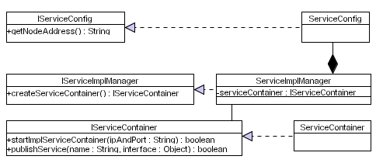
Figure 9 Service Implementation Manager

Issues
The issues associated with the Class Diagram are not known at this stage.

Requirements
Each peer service within the framework, according to our best practices, must have an associated implementation service. This requires that a service container must exist that publishes the implementation services. The service container itself may reside within the device or externally within some organisation. As such the service container must be started and each of the implementation services published.

Assumptions
This framework abstracts the underlying service technology using peer services, which ensure service interoperability, which allows any service technology to seamlessly interact with each other. The requirement ensures that the framework does not place any constraints on what service technology is being used. Starting the service container is not a mandatory process because it is possible that the service container resides outside the framework boundary because it is a generic service container used by several different systems within the organisation. Furthermore the framework does not require that implantation services are used at all and the device manufacturer is free to implement the service logic directly within a peer service itself, however this technique is restrictive, inflexible and difficult to maintain. Therefore we assume that peer and implementation services will be used in parallel.

Attributes
This Class Diagram supports several classes with each class containing zero or more attributes. Each of these attributes are listed and described below.
Class | Attribute | Description
ServiceImplManager | serviceContainer | This attribute contains a service container instance.
Table 15 Service Implementation Manager Attributes

Methods
This Class Diagram supports several classes with each class containing zero or more methods. Each of these methods are listed and described below.
Class | Method | Description
IServiceConfig | getNodeAddress | This method retrieves the node address, which is used to register the endpoint address for implementation services. For example this address could be a IP and Port address.
IServiceImplManager | createServiceContainer | This method creates a service container instance. The returned value is assigned to the serviceContainer attribute.
IServiceContainer | startImplServiceContainer | This method allows the device to start the service container.
IServiceContainer | publishService | This method allows an implementation service to be published.
Table 16 Service Implementation Manager Methods

Extensions
There are no known extensions for this Class Diagram at this stage of the design.

Class Diagram: Peer Service Manager

Description
This Class Diagram illustrates the classes required for the Peer Service Manager within this framework. The Class Diagram is illustrated in Figure 10.
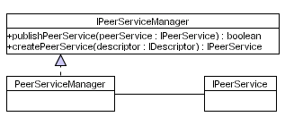
Figure 10 Peer Service Manager

Issues
The issues associated with the Class Diagram are not known at this stage.

Requirements
The peer service manager must create and start each peer service used by a device. When a peer service is created a descriptor file can be used that provides all the service advertisement information, which must include the service ontologies. Alternatively the descriptions can be hard within the peer service object itself. Once a peer service is created it must be published – in this instance the input endpoint is created, which must receive all incoming messages for that peer service.

Assumptions
The assumptions for this Class Diagram are not known at this stage of the design.

Attributes
This Class Diagram supports several classes with each class containing zero or more attributes. Each of these attributes are listed and described below.
Class | Attribute | Description
N/A | N/A | N/A
Table 17 Peer Service Manager Attributes

Methods
This Class Diagram supports several classes with each class containing zero or more methods. Each of these methods are listed and described below.
Class | Method | Description
IPeerServiceManager | publishPeerService | This method allows the device to publish a particular peer service.
IPeerServiceManager | createPeerService | This method allows the device to create a peer service using a descriptor file.
Table 18 Peer Service Manager Methods

Extensions
There are no known extensions for this Class Diagram at this stage of the design.

Class Diagram: Peer Service Advertisement

Description
This Class Diagram illustrates the required classes to create Peer Service Advertisements within this framework. The Class Diagram is illustrated in Figure 11.
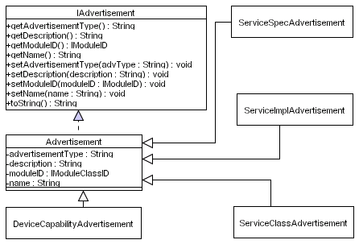
Figure 11 Peer Service Advertisement Classes

Issues
The issues associated with the Class Diagram are not known at this stage.

Requirements
Peer services must provide information about the service itself, the specifications it uses and details about the implementation of those specifications. This must be achieved by creating advertisements. These advertisements must contain semantic information that describes the service in terms of its capabilities, which must include the service interface – the type of service interface used is dependent on the service technology. An advertisement must be created from an Advertisement object or one of its subclasses. Service advertisement objects themselves must also be serialised as XML in order to publish the Peer Services functions locally and remotely within the P2P network.

Assumptions
It is envisaged that each Peer Service will need a Service Class object, one or more Service Specification objects and one or more Service Implementation objects. These objects will effectively capture and advertise the Peer Service and the functions it provides in terms of its capabilities. It is also envisaged that Advertisement objects will be used if application specific advertisements are required. Furthermore any of the service objects can be sub classed to create new or specialised advertisements. The framework provides this level of flexibility.

Attributes
This Class Diagram supports several classes with each class containing zero or more attributes. Each of these attributes are listed and described below.
Class | Attribute |  | Description
Advertisement |  | advertisementType |  | This attribute contains a value describing the type of advertisement, i.e. Class Advertisement, Specification Advertisement, an Implementation Advertisement or an Application Specific Advertisement.
Advertisement |  | description |  | This attribute contains a description of the advertisement. This attribute must typically be assigned the Service Profile Ontology.
Advertisement |  | moduleID |  | This attribute is a unique ID that is used to identify the advertisement.
Advertisement |  | name |  | This attribute contains the name of the advertisement, which is not guaranteed to be unique.
Table 19 Peer Service Advertisement Attributes

Methods
This Class Diagram supports several classes with each class containing zero or more methods. Each of these methods are listed and described below.
Class | Method | Description
IAdvertisement | getAdvertisementType | This method allows the advertisement type value to be retrieved.
IAdvertisement | getDescription | This method allows the description value to be retrieved.
IAdvertisement | getModuleID | This method allows the unique module ID to be retrieved.
IAdvertisement | getName | This method allows the name of the advertisement to be retrieved.
IAdvertisement | setAdvertisementType | This method sets the advertisement type value. The value is assigned to the advertisementType attribute.
IAdvertisement | setDescription | This method sets the advertisement description value. This value is assigned to the description attribute.
IAdvertisement | setModuleID | This method sets the unique module ID value. This value is assigned to the moduleClassID attribute.
IAdvertisement | setName | This method sets the name of the advertisement. This value is assigned to the name attribute.
IAdvertisement | toString | This method serialises the advertisement object into a XML advertisement.
Table 20 Peer Service Advertisement Methods

Extensions
There are no known extensions for this Class Diagram at this stage of the design.

Class Diagram: Service Class Advertisement

Description
This Class Diagram illustrates the classes required to create a Service Class Advertisement within this framework. The Class Diagram is illustrated in Figure 12.
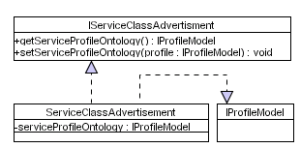
Figure 12 Service Class Advertisement Classes

Issues
The issues associated with the Class Diagram are not known at this stage.

Requirements
When a Peer Service is used a Service Class Advertisement must be created to advertise the behaviours the Peer Service provides. This advertisement must be uniquely identified and used to group all the associated Service Specification and Service Implementation advertisements. A Service Class Advertisement object must implement the IProfileModel, which allows the Peer Service to be semantic discovered within the P2P network based on its capabilities.

Assumptions
When the Service Class Advertisement is serialised, the serialisation must also include the Service Profile Model. The framework does not place any constraints on how the objects are serialised, however the XML notation generated must be based on RDF(S) structures. This is left to the device manufacturer and the code to achieve this must be placed in the toString method.

Attributes
This Class Diagram supports several classes with each class containing zero or more attributes. Each of these attributes are listed and described below.
Class | Attribute | Description
ServiceClassAdvertisement | serviceProfileOntology | This attribute contains the service profile ontology metadata that semantically describes the service in terms of its capabilities.
Table 21 Service Class Advertisement Attributes

Methods
This Class Diagram supports several classes with each class containing zero or more methods. Each of these methods are listed and described below.
Class | Method | Description
IServiceClassAdvertisement | getServiceProfileOntology | This method allows the device to retrieve the service ontology model from the service class advertisement.
IServiceClassAdvertisement | setServiceOntologyModel | This method allows the device to assign service profile ontology to the service class advertisement.
Table 22 Service Class Advertisement Methods

Extensions
There may be a requirement to allow device manufacturers to add their own custom parameters to advertisements. Consequently an additional attribute will be needed to contain the application specific parameters. Furthermore to accessor methods are required to add and remove these parameters.

Class Diagram: Service Specification Advertisement

Description
This Class Diagram illustrates the required classes to create a service specification advertisement within this framework. The Class Diagram is illustrated in Figure 13.
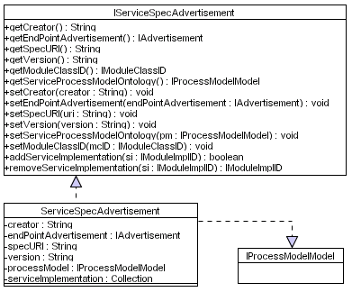
Figure 13 Service Specification Advertisement Classes

Issues
The issues associated with the Class Diagram are not known at this stage.

Requirements
When a Peer Service is used one or more Service Specification Advertisement must be created to advertise the different specifications the Peer Service implements and uses. Each Service Specification Advertisement must be uniquely identified and associated with a Service Class Advertisement and a Service Implementation Advertisement. A Service Specification Advertisement object must implement the IProcessModel, which allows the Peer Service to semantically describe all the signatures supported by the Peer Service.

Assumptions
When the Service Specification Advertisement is serialised, the serialisation must also include the Service Process Model. The framework does not place any constraints on how the objects are serialised, however the XML notation generated must be based on RDF(S) structures. This is left to the device manufacturer and the code to achieve this must be placed in the toString method.

Attributes
This Class Diagram supports several classes with each class containing zero or more attributes. Each of these attributes are listed and described below.
Class | Attribute | Description
ServiceSpecAdvertisement | creator | This attribute contains the name of the creator who developed the Service Specification.
ServiceSpecAdvertisement | endPointAdvertisement | This attribute contains the endpoint advertisement that allows devices to connect to and use the service.
ServiceSpecAdvertisement | specURI | This attribute contains the URI where the Peer Service specification can be downloaded.
ServiceSpecAdvertisement | version | This attribute contains the specification version number.
ServiceSpecAdvertisement | processModel | The attribute contains the Process Model that semantically defines abstract signatures that map onto concrete signatures in the service implementation via the Service Grounding Model.
ServiceSpecAdvertisement | serviceImplementation | This attribute contains all the Service Implementation Advertisements that implement the Service Specification.
Table 23 Service Specification Advertisement Attributes

Methods
This Class Diagram supports several classes with each class containing zero or more methods. Each of these methods are listed and described below.
Class | Method | Description
IServiceSpecAdvertisement | getCreator | This method allows the device to retrieve the creator information for the Service Specification.
IServiceSpecAdvertisement | getEndPointAdvertisement | This method allows the Endpoint Advertisement to be retrieved from the Service Specification.
IServiceSpecAdvertisement | getSpecURI | This method allows the URI for the service specification to be retrieved from the Service Specification.
IServiceSpecAdvertisement | getVersion | This method allows the specification version to be retrieved from the Service Specification.
IServiceSpecAdvertisement | getModuleClassID | This method allows the Module Class ID to be retrieved from the Service Specification.
IServiceSpecAdvertisement | getProcessModel | This method allows the Service Process Model to be retrieved from the Service Specification.
IServiceSpecAdvertisement | setCreator | This method allows the creator details to be assigned to the create attribute.
IServiceSpecAdvertisement | setEndPointAdvertisement | This method allows the Endpoint Advertisement to be assigned to the endPoint Advertisement attribute.
IServiceSpecAdvertisement | setSpecURI | This method allows the URI for the Service Specification to be assigned to the specURI attribute.
IServiceSpecAdvertisement | setVersion | This method allows the Service Specification version number to be assigned to the version attribute.
IServiceSpecAdvertisement | setProcessModel | This method allows a Process Model to be assigned to the processModel attribute.
IServiceSpecAdvertisement | setModuleClassID | This method allows the Module Class ID to be assigned to the moduleClassID attribute.
IServiceSpecAdvertisement | addServiceImplementation | This method allows a Service Implementation Advertisement to be added to the serviceImplementation collection.
IServiceSpecAdvertisement | removeServiceImplementation | This method allows a Service Implementation Advertisement to be removed from the serviceImplementation collection.
Table 24 Service Specification Advertisement Methods

Extensions
There are no known extensions for this Class Diagram at this stage of the design.

Class Diagram: Service Implementation Advertisement

Description
This Class Diagram illustrates the required classes to create a service implementation service within this framework. The Class Diagram is illustrated in Figure 14.
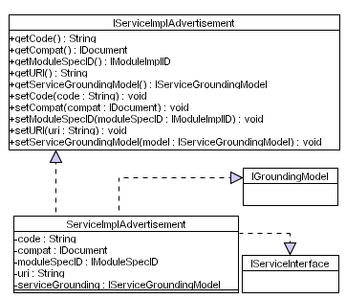
Figure 14 Service Implementation Advertisement Classes

Issues
The issues associated with the Class Diagram are not known at this stage.

Requirements
When a Peer Service is used one or more Service Implementation Advertisement must be created to advertise the different implementations of a Peer Service. Each Service Implementation Advertisement must be uniquely identified and associated with a Service Class Advertisement and a Service Specification Advertisement. A Service Implementation Advertisement object must implement the IGroundingModel and the IServieInteface, which allows the Peer Service to semantically bind abstract service descriptions using in the Service Profile and the Service Process Model with concrete signatures contained in the Service Interface.

Assumptions
When the Service Implementation Advertisement is serialised, the serialisation must also include the Service Grounding Model and the Service Interface. The framework does not place any constraints on how the objects are serialised, however the XML notation generated must be based on RDF(S) structures. This is left to the device manufacturer and the code to achieve this must be placed in the toString method.
There may be occasions when the device wishes to download the code used by an intermediary service rather than using the intermediary service remotely. For example the device may do performing real-time data adaptation therefore the delay may impinge on the quality of service if the coding is performed remotely. Consequently the device in this instance will want to download the code and adapt it locally, which may ensure minimal delays are incurred and a high quality of service is maintained. As such the Service Implementation Advertisement describes how this code can be located and downloaded.

Attributes
This Class Diagram supports several classes with each class containing zero or more attributes. Each of these attributes are listed and described below.
Class | Attribute | Description
ServiceImplAdvertisement | code | This attribute contains the service interface. For example this could be a WSDL file/URI.
ServiceImplAdvertisement | compat | This attribute contains information about compatibility issues relating to the Peer Service implementation.
ServiceImplAdvertisement | moduleSpecID | This attribute contains the Module Specification ID for the advertisement the Service Implementation realises.
ServiceImplAdvertisement | uri | This attribute contains a reference to the location where the package/executable code can be downloaded/loaded from.
ServiceImplAdvertisement | serviceGrounding | This attribute contains the Service Grounding for the implementation.
Table 25 Service Implementation Advertisement Attributes

Methods
This Class Diagram supports several classes with each class containing zero or more methods. Each of these methods are listed and described below.
Class | Method | Description
IServiceImplAdvertisement | getCode | This method allows the device to retrieve the service interface from the Service Implementation Advertisement.
IServiceImplAdvertisement | getCompat | This method allows the device to retrieve compatibility information for this Peer Service Implementation from the Service Implementation Advertisement.
IServiceImplAdvertisement | getModuleSpecID | This method allows the device to retrieve the Module Spec ID from the Service Implementation Advertisement.
IServiceImplAdvertisement | getURI | This method allows the device to retrieve the URI from the Service Implementation Advertisement for either downloading a package or executable code.
IServiceImplAdvertisement | getServiceGrounding | This method allows the device to retrieve the Service Grounding from the Service Implementation Advertisement.
IServiceImplAdvertisement | setCode | This method allows the device to assign the code to the code attribute.
IServiceImplAdvertisement | setCompat | This method allows the device to assign the compatibility information to the compat attribute.
IServiceImplAdvertisement | setModuleSpecID | This method allows the device to assign the Module Spec ID to the moduleSpecID attribute.
IServiceImplAdvertisement | setURI | This method allows the device to assign the URI to the uri attribute.
IServiceImplAdvertisement | setServiceGrounding | This method allows the device to assign a Service Grounding to the serviceGrounding attribute.
Table 26 Service Implementation Advertisement Methods

Extensions
There are no known extensions for this Class Diagram at this stage of the design.

Class Diagram: Service Ontology Model

Description
This Class Diagram illustrates the required classes to create a Service Ontology Model within this framework. The Class Diagram is illustrated in Figure 15.
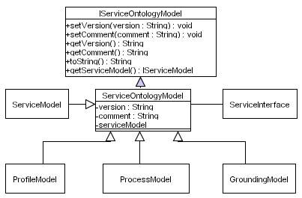
Figure 15 Service Ontology Model

Issues
The issues associated with the Class Diagram are not known at this stage.

Requirements
Each peer service provided by a device must be described semantically using service ontologies that map abstract descriptions to concrete signatures in the Service Interface. Each peer service must have a Service Model, a Profile Model, a Process Model and a Grounding Model. These service ontologies describe a service in terms of its capabilities which allows other devices within the P2P network to semantic discover services and reason over how they can be integrated within a service composition.

Assumptions
The framework does not place any constraints on how the Service Ontology Models are serialised, however the XML notation generated must be based on RDF(S) structures. This is left to the device manufacturer and the code to achieve this must be placed in the toString method.

Attributes
This Class Diagram supports several classes with each class containing zero or more attributes. Each of these attributes are listed and described below.
Class | Attribute | Description
ServiceOntologyModel | version | This attribute contains the ontology model version.
ServiceOntologyModel | comment | This attribute contains descriptive text about the ontology model
ServiceOntologyModel | serviceModel | This attribute contains the information regarding the Service Model the Service Profile belongs to.
Table 27 Service Ontology Model Attributes

Methods
This Class Diagram supports several classes with each class containing zero or more methods. Each of these methods are listed and described below.
Class | Method | Description
IServiceOntologyModel | setVersion | This method allows a version number to be assigned to the version attribute.
IServiceOntologyModel | setComment | This method allows a comment to be assigned to the comment attribute.
IServiceOntologyModel | getVersion | This method allows the version information to be retrieved from the version attribute.
IServiceOntologyModel | getComment | This method allows the comment information to be retrieved from the comment attribute.
IServiceOntologyModel | toString | This method serialises the ontology model object into an XML format.
IServiceOntologyModel | getServiceModel | This method allows the Service Model associated with the Service Process Model to be retrieved.
Table 28 Service Ontology Model Methods

Extensions
There are no known extensions for this Class Diagram at this stage of the design.

Class Diagram: Service Model

Description
This Class Diagram illustrates the required classes needed to create a Service Model within this framework. The Class Diagram is illustrated in Figure 17.
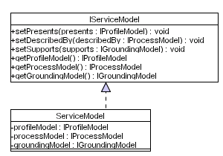
Figure 16 Service Model

Issues
The issues associated with the Class Diagram are not known at this stage.

Requirements
The Service Model provides an efficient way of organising the different parts of the service description. It must contain the Service Profile Model, the Service Process Model and the Service Grounding Model. When the Service Model is first created each of these ontology models must be created and added to the Service Model.

Assumptions
The framework does not place any constraints on how the Service Model is serialised, however the XML notation generated must be based on RDF(S) structures. This is left to the device manufacturer and the code to achieve this must be placed in the toString method.

Attributes
This Class Diagram supports several classes with each class containing zero or more attributes. Each of these attributes are listed and described below.
Class | Attribute | Description
ServiceModel | profileModel | This attribute contains the profile model for the peer service.
ServiceModel | processModel | This attribute contains the process model for the peer service.
ServiceModel | groundingModel | This model contains the grounding model for the peer service.
Table 29 Service Model Attributes

Methods
This Class Diagram supports several classes with each class containing zero or more methods. Each of these methods are listed and described below.
Class | Method | Description
IServiceModel | setPresents | This method allows a profile model to be assigned to the service model.
IServiceModel | setDescribedBy | This method allows a process model to be assigned to the service model.
IServiceModel | setSupports | This method allows a grounding model to be assigned to the service model.
IServiceModel | getProfileModel | This method allows the profile model to be retrieved.
IServiceModel | getProcessModel | This method allows the process model to be retrieved.
IServiceModel | getGroundingModel | This method allows the grounding model to be retrieved.
Table 30 Service Model Methods

Extensions
There are no known extensions for this Class Diagram at this stage of the design.

Class Diagram: Service Profile Model

Description
This Class Diagram illustrates the required classes need to create a Service Profile Model within this framework. The Class Diagram is illustrated in Figure 17.
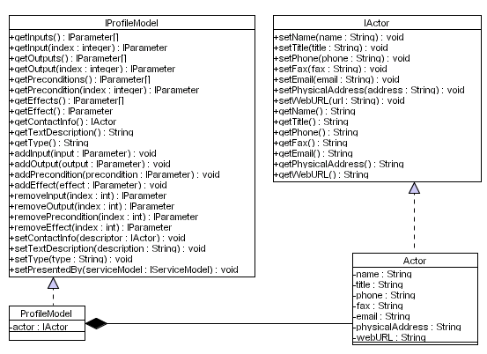
Figure 17 Service Profile Model

Issues
The issues associated with the Class Diagram are not known at this stage.

Requirements
The Service Profile Model tells you what the service does. The Service Profile Model must be associated with a Service Model. The Service Profile Model must describe what the service does and who the creator of the service is. The creator information must be captured in an Actor object, which must include the actors name, address, email and Web address to name a few. The Service Profile Model must capture all the Inputs, Outputs, Preconditions and Effects used by the service. Each Input and Output must also be associated with an Atomic Process in the Service Process Model. This model must also be described and the type information associated with the service must be described.

Assumptions
The framework does not place any constraints on how the Service Profile Model is serialised, however the XML notation generated must be based on RDF(S) structures. This is left to the device manufacturer and the code to achieve this must be placed in the toString method.

Attributes
This Class Diagram supports several classes with each class containing zero or more attributes. Each of these attributes are listed and described below.
Class | Attribute | Description
ProfileModel | actor | This attribute contains information about the person/organisation that created the Service Profile.
Actor | name | This attribute contains the person’s name that created the Service Profile.
Actor | title | This attribute contains the title of the Service Profile.
Actor | phone | This attribute contains the phone number for the person described in the name attribute.
Actor | fax | This attribute contains the fax number for the person described in the name attribute.
Actor | email | This attribute contains the email address for the person described in the name attribute.
Actor | physicalAddress | This attribute contains the address details for the person described in the name attribute.
Actor | webURL | This attribute contains the Web address for the person described in the name attribute.
Table 31 Service Profile Model Attributes

Methods
This Class Diagram supports several classes with each class containing zero or more methods. Each of these methods are listed and described below.
Class | Method | Description
IProfileModel | getInputs | This method allows the Inputs to be retrieved from the Service Profile.
IProfileModel | getInput | This method allows an Input to be retrieved from the Service Profile.
IProfileModel | getOutputs | This method allows the Outputs to be retrieved from the Service Profile.
IProfileModel | getOutput | This method allows an Output to be retrieved from the Service Profile.
IProfileModel | getPreconditions | This method allows the Preconditions to be retrieved from the Service Profile.
IProfileModel | getPrecondition | This method allows a Precondition to be retrieved from the Service Profile.
IProfileModel | getEffects | This method allows the Effects to be retrieved from the Service Profile.
IProfileModel | getEffect | This method allows an Effect to be retrieved from the Service Profile.
IProfileModel | getContactInfo | This method returns an Actor object instance assigned to the actor attribute.
IProfileModel | getTextDescription | This method returns the text description for the Service Profile.
IProfileModel | getType | This method returns a URI that represents the profile's type in some profile hierarchy. By default the type of a profile will be profile:Profile.
IProfileModel | addInput | This method adds an Input to the input attribute.
IProfileModel | addOutput | This method adds an Output to the output attribute.
IProfileModel | addPrecondition | This method adds a Precondition to the precondition attribute.
IProfileModel | addEffect | This method adds an Effect to the effect attribute.
IProfileModel | removeInput | This method removes an Input from the input attribute.
IProfileModel | removeOutput | This method removes an Output from the output attribute.
IProfileModel | removePrecondition | This method removes a Precondition from the precondition attribute.
IProfileModel | removeEffect | This method removes an Effect from the effect attribute.
IProfileModel | setContactInfo | This method assigns an Actor object to the contactInfo attribute.
IProfileModel | setTextDescription | This method assigns some descriptive text to the textDescription attribute, which describes the Service Profile.
IProfileModel | setType | This method assigns a URI that represents the profile’s type in some profile hierarchy.
IProfileModel | setPresentedBy | This method assigns a Service Model object that the Service Profile is associated with.
Table 32 Service Profile Model Methods

Extensions
It may be desirable to assign a service category object to the Service Profile. The service category will be an ontological structure that semantically describes the service category the peer service belongs to. This will help the service discovery process to better infer whether the service is capable of providing the required behaviours.

Class Diagram: Service Process Model

Description
This Class Diagram illustrates the classes required to create a service process ontology model within this framework. The Class Diagram is illustrated in Figure 18.
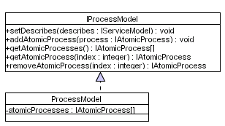
Figure 18 Service Process Model

Issues
The issues associated with the Class Diagram are not known at this stage.

Requirements
The Service Process Model tells you have the service works. This model must reference the Service Model it is associated with. It must allow Atomic Process to be added, retrieved and removed from the model. Atomic Processes must act as abstract semantic descriptions of concrete signatures contained in the Service Interface. Atomic Process must only describe a signature in terms of the inputs it takes and the output it produces, which must also include the data type for each parameter used. There is no requirement to specify the method name as we are only interested in the capabilities of the service – these capabilities are matched with actual signatures and if a match is found the service name including the parameter order information can be directly extracted from the service interface itself.

Assumptions
The framework does not place any constraints on how the Service Process Model is serialised, however the XML notation generated must be based on RDF(S) structures. This is left to the device manufacturer and the code to achieve this must be placed in the toString method.

Attributes
This Class Diagram supports several classes with each class containing zero or more attributes. Each of these attributes are listed and described below.
Class | Attribute | Description
ProcessModel | atomicProcesses | This attribute contains all the Atomic Processes used by the Peer Service
Table 33 Service Process Model Attributes

Methods
This Class Diagram supports several classes with each class containing zero or more methods. Each of these methods are listed and described below.
Class | Method | Description
IProcessModel | setDescribes | This method assigns the Service Model the Service Process Model is associated with.
IProcessModel | addAtomicProcess | This method adds an Atomic Process to the Model.
IProcessModel | getAtomicProcesses | This method allows a collection of Atomic Processes to be retrieved from the atomicProcesses attribute collection
IProcessModel | getAtomicProcess | This method allows a single Atomic Process to be retrieved from the atomicProcesses attribute collection.
IProcessModel | removeAtomicProcess | This method allows a single Atomic Process to be removed from the atomicProcesses attribute collection.
Table 34 Service Process Model Methods

Extensions
There are no known extensions for this Class Diagram at this stage of the design.

Class Diagram: Atomic Process

Description
This Class Diagram illustrates the classes required to create an Atomic Process within this framework. The Class Diagram is illustrated in Figure 19.
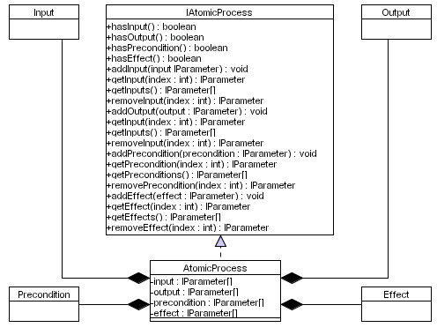
Figure 19 Atomic Process

Issues
The issues associated with the Class Diagram are not known at this stage.

Requirements
Atomic Processes must be used in the Service Process Model to logically group inputs, outputs, preconditions and effects to form abstract semantic signatures. These atomic processes must map directly onto Atomic Process Groundings in the Service Grounding Model.

Assumptions
The framework does not place any constraints on how Atomic Processes are serialised, however the XML notation generated must be based on RDF(S) structures.

Attributes
This Class Diagram supports several classes with each class containing zero or more attributes. Each of these attributes are listed and described below.
Class | Attribute | Description
AtomicProcess | input | This attribute contains a collection of inputs used within the Atomic Process.
AtomicProcess | output | This attribute contains a collection of outputs used within the Atomic Process.
AtomicProcess | precondition | This attribute contains a collection of preconditions used within the Atomic Process.
AtomicProcess | effect | This attributed contains a collection of effects used within the Atomic Process.
Table 35 Atomic Process Attributes

Methods
This Class Diagram supports several classes with each class containing zero or more methods. Each of these methods are listed and described below.
Class | Method | Description
IAtomicProcess | hasInput | This method returns a Boolean value true or false depending on whether the Atomic Process has any Inputs.
IAtomicProcess | hasOutput | This method returns a Boolean value true or false depending on whether the Atomic Process has any Outputs.
IAtomicProcess | hasPrecondition | This method returns a Boolean value true or false depending on whether the Atomic Process has any Preconditions.
IAtomicProcess | hasEffect | This method returns a Boolean value true or false depending on whether the Atomic Process has any Effects.
IAtomicProcess | addInput | This method allows an Input to be added to the input attribute collection.
IAtomicProcess | getInput | This method allows a specific Input to be retrieved from the input attribute collection using an index.
IAtomicProcess | getInputs | This method allows all the Inputs to be retrieved from the input attribute – the attribute is returned.
IAtomicProcess | removeInput | This method allows an Onput to be removed from the input attribute collection using a specified index value.
IAtomicProcess | addOutput | This method allows an Output to be added to the output attribute collection.
IAtomicProcess | getOutput | This method allows a specific Output to be retrieved from the output attribute collection using an index.
IAtomicProcess | getOutputs | This method allows all the Outputs to be retrieved from the output attribute – the attribute is returned.
IAtomicProcess | removeOutput | This method allows an Output to be removed from the output attribute collection using a specified index value.
IAtomicProcess | addPrecondition | This method allows a Precondition to be added to the precondition attribute collection.
IAtomicProcess | getPrecondition | This method allows a specific Precondition to be retrieved from the precondition attribute collection using an index.
IAtomicProcess | getPreconditions | This method allows all the Preconditions to be retrieved from the precondition attribute – the attribute is returned.
IAtomicProcess | removePrecondition | This method allows a Precondition to be removed from the precondition attribute collection using a specified index value.
IAtomicProcess | addEffect | This method allows an Effect to be added to the effect attribute collection.
IAtomicProcess | getEffect | This method allows a specific Effect to be retrieved from the effect attribute collection using an index.
IAtomicProcess | getEffects | This method allows all the Effects to be retrieved from the effect attribute – the attribute is returned.
IAtomicProcess | removeEffect | This method allows an Effect to be removed from the effect attribute collection using a specified index value.
Table 36 Atomic Process Methods

Extensions
There are no known extensions for this Class Diagram at this stage of the design.

Class Diagram: Parameter

Description
This Class Diagram illustrates the classes required to create a Parameter within this framework. The Class Diagram is illustrated in Figure 20.
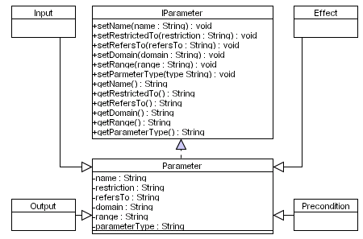
Figure 20 Parameter

Issues
The issues associated with the Class Diagram are not known at this stage.

Requirements
Parameters must be used in the Service Profile and Atomic Processes in the Service Process Model to capture the inputs and outputs service signatures support within the Service Interface including preconditions and effects. Depending in which context a parameter is created will depend on what methods need to be implemented. If an IOPE is used in the Service Profile then the developer will have to assign the restriction on the IOPE including the domain, range and parameter type. If an IOPE is used in an Atomic Process then the only assignments that need to take place will be the name and the parameter type – all other methods must be implemented, however they will not require any code.

Assumptions
The framework does not place any constraints on how the Parameter is serialised, however the XML notation generated must be based on RDF(S) structures.

Attributes
This Class Diagram supports several classes with each class containing zero or more attributes. Each of these attributes are listed and described below.
Class | Attribute | Description
Parameter | name | This attribute contains the name of the parameter.
Parameter | restriction | This attribute contains information about the restriction associated with the Parameter. A restriction may be that an integer value must be less than 10 for example.
Parameter | referesTo | This attribute contains the refers to value that links an IOPE in the Service Profile with an Atomic Process in the Service Process Model.
Parameter | domain | This attribute contains the domain in which an IOPE exists. For example an input called Age may exist in the domain of Person.
Parameter | range | This attribute contains the range in which an IOPE exists. For example a input called Person will have a range of Male and Female.
Parameter | parameterType | This attribute contains the parameter type information. For example Input, Output, Precondition or Effect.
Table 37 Parameter Attributes

Methods
This Class Diagram supports several classes with each class containing zero or more methods. Each of these methods are listed and described below.
Class | Method | Description
IParameter | setName | This method allows the name of a parameter to be assigned to the name attribute.
IParameter | setRestrictedTo | This method allows the restrictedTo value to be assigned to the restriction attribute.
IParameter | setRefersTo | This method allows the refersTo value to be assigned to the referesTo attribute.
IParameter | setDomain | This method allows the domain in which the parameter exists to be assigned to the domain attribute.
IParameter | setRange | This method allows the range of values the parameter is allowed to contain to be assigned to the range attribute.
IParameter | setParameterType | This method allows the parameter type value to be assigned to the parameterType attribute.
IParameter | getName | This method allows the value of the name attribute to be retrieved.
IParameter | getRestrictedTo | This method allows the value of the restrictedTo attribute to be retrieved.
IParameter | getRefersTo | This method allows the value of the refersTo attribute to be retrieved.
IParameter | getDomain | This method allows the value of the domain attribute to be retrieved.
IParameter | getRange | This method allows the value of the range attribute to be retrieved.
IParameter | getParameterType | This method allows the value of the parameter type to be retrieved.
Table 38 Parameter Methods

Extensions
There are no known extensions for this Class Diagram at this stage of the design.

Class Diagram: The Service Grounding Model

Description
This Class Diagram illustrates the classes required to create a service process ontology model within this framework. The Class Diagram is illustrated in Figure 21.
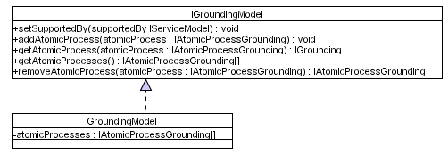
Figure 21 Service Grounding Model

Issues
The issues associated with the Class Diagram are not known at this stage.

Requirements
The Service Grounding tells you how the service can be accessed and controlled. This model must contain the Service Model the Service Grounding Model belongs to. A Service Grounding model must consist of Atomic Processes that describe the abstract signatures in the Service Process Model and explicitly bind to signatures contained in the Service Interface. Consequently the Grounding Model object must provide mechanisms to add retrieve and remove Atomic Processes from the model.

Assumptions
The framework does not place any constraints on how the Service Grounding Model is serialised, however the XML notation generated must be based on RDF(S) structures. This is left to the device manufacturer and the code to achieve this must be placed in the toString method.

Attributes
This Class Diagram supports several classes with each class containing zero or more attributes. Each of these attributes are listed and described below.
Class | Attribute | Description
GroundingModel | atomicProcesses | This attribute contains all the Atomic Process Groundings used to describe the service signatures at an abstract semantic level.
Table 39 Service Grounding Model Attributes

Methods
This Class Diagram supports several classes with each class containing zero or more methods. Each of these methods are listed and described below.
Class | Method | Description
IGroundingModel | setSupportedBy | This method allows the Service Model associated with the Service Grounding Model to be assigned to the serviceModel attribute.
IGroundingModel | addAtomicProcess | This method allows an Atomic Process Grounding to be added to the atomicProcessGrounding attribute.
IGroundingModel | getAtomicProcess | The method allows an Atomic Process Grounding to be retrieved from the atomicProcessGrounding using a specified index.
IGroundingModel | getAtomicProcesses | This method allows all the Atomic Process Groundings to be retrieved from the atomicProcessGrounding attribute.
IGroundingModel | removeAtomicProcess | The method allows an Atomic Process Grounding to be removed from the atomicProcessGrounding attribute.
Table 40 Service Grounding Model Methods

Extensions
There are no known extensions for this Class Diagram at this stage of the design.

Class Diagram: Atomic Process Grounding

Description
This Class Diagram illustrates the classes required to create an Atomic Process Grounding within this framework. The Class Diagram is illustrated in Figure 22.
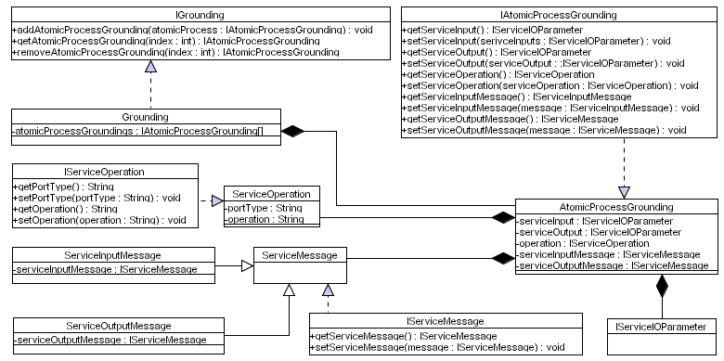
Figure 22 Atomic Process Grounding

Issues
The issues associated with the Class Diagram are not known at this stage.

Requirements
The Service Grounding tells you how the service can be accessed and controlled. The grounding must contain one or more AtomicProcessGroundings, which they must contain a Service Inputs object, a Service Outputs object, a Service Operation object, a Service Input Message object and a Service Output Message object. These objects allow the IOPEs in the Atomic Process Grounding object to be mapped onto concrete signature bindings in the Service Interface. The requirements for this Class Diagram are not known at this stage of the design.

Assumptions
The framework does not place any constraints on how the Atomic Process Grounding is serialised, however the XML notation generated must be based on RDF(S) structures.

Attributes
This Class Diagram supports several classes with each class containing zero or more attributes. Each of these attributes are listed and described below.
Class | Attribute | Description
Grounding | atomicProcessGrounding | This attribute contains all the Atomic Process Groundings the Service Grounding Model contains.
Grounding | serviceModel | This attribute contains the Service Model the
AtomicProcessGrounding | serviceInput | This attribute contains the service Inputs.
AtomicProcessGrounding | serviceOutput | This attribute contains the service Outputs.
AtomicProcessGrounding | operation | This attribute contains the operation name that used by the required signature.
AtomicProcessGrounding | serviceInputMessage | This attribute contains a URL that links the Atomic Process Grounding to an input message in the Service Interface.
AtomicProcessGrounding | serviceOutputMessage | This attribute contains a URL that links the Atomic Process Grounding to an output message in the Service Interface.
ServiceOperation | portType | This attribute contains a URL address that points to the portType element in the Service Interface.
ServcieOperation | operation | This attribute contains a URL address that points to the operation name in the Service Interface.
Table 41 Atomic Process Grounding Attributes

Methods
This Class Diagram supports several classes with each class containing zero or more methods. Each of these methods are listed and described below.
Class | Method | Description
IGrounding | addAtomicProcessGrounding | This method allows an Atomic Process Grounding to be added to the atomicProcessGrounding Attribute.
IGrounding | getAtomicProcessGrounding | This method allows an Atomic Process Grounding to be retrieved from the atomicProcessGrounding Attribute.
IGrounding | removeAtomicProcessGrounding | This method allows an Atomic Process Grounding to be removed from the atomicProcessGrounding Attribute.
IAtomicProcessGrounding | getServiceInput | This method allows Service Inputs to be retrieved for a particular Atomic Process Grounding.
IAtomicProcessGrounding | setServiceInput | This method allows the Service Inputs to be set for a particular Atomic Process Grounding.
IAtomicProcessGrounding | getServiceOutput | This method allows the Service Outputs to be retrieved for a particular Atomic Process Grounding.
IAtomicProcessGrounding | setServiceOutput | This method allows the Service Outputs to be set for a particular Atomic Process Grounding.
IAtomicProcessGrounding | getServiceOperation | This method allows the Service Operation to be retrieved for a particular Atomic Process Grounding.
IAtomicProcessGrounding | setServiceOperation | This method allows the operation to be set for a particular Atomic Process Grounding.
IAtomicProcessGrounding | getServiceInputMessage | This Method allows the Service Input Message to be retrieved which maps onto a message in the Service Interface.
IAtomicProcessGrounding | setServiceInputMessage | This method allows the Service Input Message to be set which maps onto a message in the Service Interface.
IAtomicProcessGrounding | getServiceOutputMessage | This method allows the Service Output Message to be retrieved which maps onto a message in the Service interface.
IAtomicProcessGrounding | setServiceOutputMessage | This method allows the Service Output Message to be set which maps onto a message in the Service Interface.
IServiceOperation | getPortType | This method allows the portType URL which maps onto a port Type in the Service Interface to be retrieved.
IServiceOperation | setPortType | This method allows the portType URL which maps onto a port Type in the Service Interface to be set.
IServiceOperation | getOperation | This method allows the operation URL which maps onto an operation in the Service Interface to be retrieved.
IServiceOperation | setOperation | This method allows the operation URL which maps onto an operation in the Service Interface to be set.
IServiceMessage | getServiceMessage | This method allows a Service Message which maps the Atomic Process Grounding to a message in the Service Interface to be retrieved.
IServiceMessage | setServiceMessage | This method allows a Service Message which maps the Atomic Process Grounding to a message in the Service Interface to be set.
Table 42 Atomic Process Grounding Methods

Extensions
There are no known extensions for this Class Diagram at this stage of the design.

Class Diagram: Service Input/Output Parameter

Description
This Class Diagram illustrates the classes required to create a Service Input/Output Parameter within this framework. The Class Diagram is illustrated in Figure 23.
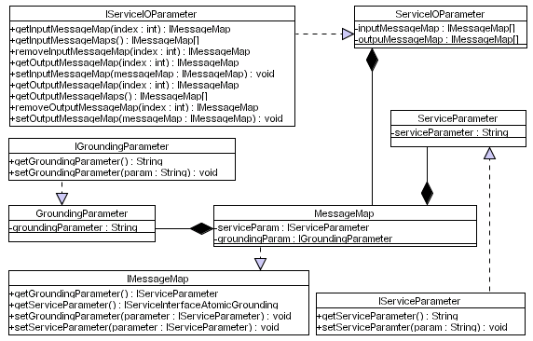
Figure 23 Service Input/Output Parameter

Issues
The issues associated with the Class Diagram are not known at this stage.

Requirements
ServiceIOParameters are used to create Inputs and Outputs that map the Service Grounding Atomic Process Inputs and Outputs to parameters in a signature contained in the Service Interface. The Service IO Parameter must contain one or more Message Map objects which contain two objects; the first object is the Service Parameter, which contains information about a parameter in the Service Interface and the second object that contains a Grounding Parameter, which contains information about the parameter in the Service Grounding Atomic Process.

Assumptions
The framework does not place any constraints on how the Service IO Parameter is serialised, however the XML notation generated must be based on RDF(S) structures.

Attributes
This Class Diagram supports several classes with each class containing zero or more attributes. Each of these attributes are listed and described below.
Class | Attribute | Description
ServiceIOParameters | inputMessageMap | This attribute contains all the service/grounding input maps for a particular Atomic Process.
ServiceIOParameters | outputMessageMap | This attribute contains all the service/grounding output maps for a particular Atomic Process.
ServiceParameter | serviceParameter | This method contains the service parameter URL, which points to an input/output in the Service Interface.
GroundingParameter | groundingParameter | This method contains the grounding parameter URL, which points to an input/output in the Service Interface.
MessageMap | serviceParam | This attribute contains the service parameter.
MessageMap | groundingParam | This attribute contains the grounding parameter.
Table 43 Service IO Parameter Attributes

Methods
This Class Diagram supports several classes with each class containing zero or more methods. Each of these methods are listed and described below.
Class | Method | Description
IServiceIOParameters | getInputMessageMap | This method allows an Input Message Map to be retrieved from the inputMessageMap attribute using a specified index.
IServiceIOParameters | getInputMessageMaps | This method allows all the Input Message Maps to be retrieved from the inputMessageMap object – the inputMessageMap collection is returned.
IServiceIOParameters | removeInputMessageMap | This method allows an Input Message Map to be removed from the inputMessageMap attribute collection.
IServiceIOParameters | addInputMessageMap | This method allows an Input Message Map to be added to the inputMessageMap attribute collection.
IServiceIOParameters | getOutputMessageMap | This method allows an Output Message Map to be retrieved from the outputMessageMap attribute using a specified index.
IServiceIOParameters | getOutputMessageMaps | This method allows all the Output Message Maps to be retrieved from the outputMessageMap object – the outputMessageMap collection is returned.
IServiceIOParameters | removeOutputMessageMap | This method allows an Output Message Map to be removed from the outputMessageMap attribute collection.
IServiceIOParameters | addOutputMessageMap | This method allows an Output Message Map to be added to the outputMessageMap attribute collection.
Table 44 Service IO Parameter Methods

Extensions
There are no known extensions for this Class Diagram at this stage of the design.

Class Diagram: Service Interface Model

Description
This Class Diagram illustrates the classes required to create a service interface model within this framework. The Class Diagram is illustrated in Figure 24.
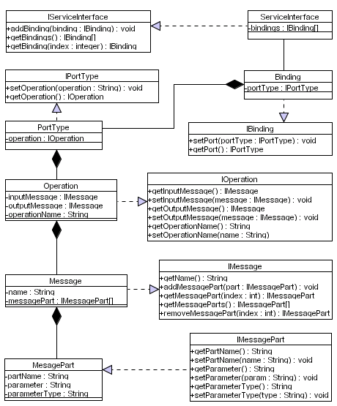
Figure 24 Service Interface Model

Issues
The issues associated with the Class Diagram are not known at this stage.

Requirements
The Service Interface must describe all the signatures a particular service supports. Each signature is known as a binding and a Service Interface may support several bindings. Each binding must contain a portType, which contains an operation. An operation must contain an input message object that describes all the inputs the signature supports and an output message object that describes the output the signature returns (if a return value is used). Each message must contain the name of the message and one or more message parts. Each message part must contain the name of the part name, the parameter and the parameters data type.

Assumptions
The framework does not place any constraints on how the Service Interface is serialised, however the notation generated must be based on XML structures.

Attributes
This Class Diagram supports several classes with each class containing zero or more attributes. Each of these attributes are listed and described below.
Class | Attribute | Description
ServiceInterface | bindings | This attribute contains all the bindings the service supports
Binding | portType | This attribute contains the port type that belongs to a particular binding.
PortType | operation | This attribute contains the operation that belongs to a particular port type.
Operation | inputMessage | This attribute contains the input message that belongs to a particular operation.
Operation | outputMessage | This attribute contains the output message that belongs to a particular operation.
Operation | operationName | This attribute contains the operation name
Message | name | This attribute contains the method name.
Message | messagePart | This attribute contains one or more message parts associated with a message.
MessagePart | partName | This attribute contains the part name for a particular message part.
MessagePart | parameter | This attribute contains the parameter name for a particular message part.
MessagePart | parameterType | This attribute contains the parameter type information for a particular parameter.
Table 45 Service Interface Attributes

Methods
This Class Diagram supports several classes with each class containing zero or more methods. Each of these methods are listed and described below.
Class | Method | Description
IServiceInterface | addBinding | This method allows a binding to be added to the binding attribute collection.
IServiceInterface | getBinding | This method allows a binding to be retrieved from the binding attribute collection.
IServiceInterface | getBindings | This method allows all the bindings to be retrieved from the binding attribute collection.
IPortType | setOperation | This method allows an operation object to be assigned to the operation attribute.
IPortType | getOperation | The method allows the operation to be retrieved from the operation attribute.
IBinding | setPort | This method allows a port type to be assigned to the portType attribute.
IBinding | getPort | This method allows the port type object to be retrieved from the portType attribute
IOperation | getInputMessage | This method allows the input message object to be retrieved from the inputMessage attribute.
IOperation | setInputMessage | This method allows an input message object to be assigned to the inputMessage object.
IOperation | getOutputMessage | This method allows the output message object to be retrieved from the outputMessage attribute.
IOperation | setOutputMessage | This method allows the output message object to be assigned to the outputMessage attribute.
IOperation | getOperationName | This method allows the operation name to be retrieved from the operationName attribute.
IOperation | setOperationName | This method allows the operation name to be assigned to the operationName attribute.
IMessage | getName | This method allows the message name to be retrieved from the message attribute.
IMessage | addMessagePart | This method allows a message part to be added to the messagePart attribute.
IMessage | getMessagePart | This method allows a message part to be retrieved from the messagePart attribute given an index.
IMessage | getMessageParts | This method allows all the message parts to be retrieved from the messagePart attribute.
IMessage | removeMessagePart | This method allows a message part to be removed from the messagePart attribute given a specific index.
IMessagePart | getPartName | This method allows the message part name to be retrieved from the partName attribute.
IMessagePart | getParameter | This method allows the message part parameter to be retrieved from the parameter attribute.
IMessagePart | getParameterType | This method allows the parameter type to be retrieved from the parameterType attribute.
Table 46 Service Interface Methods

Extensions
There are no known extensions for this Class Diagram at this stage of the design.

Class Diagram: Device Capability Advertisement

Description
This Class Diagram illustrates the classes required to create a device capability advertisement within this framework. The Class Diagram is illustrated in Figure 25.
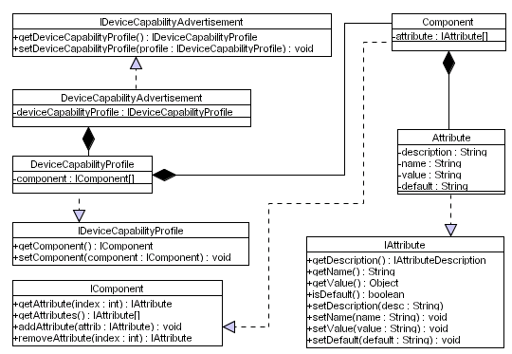
Figure 25 Device Capability Advertisement

Issues
The issues associated with the Class Diagram are not known at this stage.

Requirements
Devices must create and publish Device Capability Advertisements that capture all the key hardware, software and network capabilities. The Device Capability Advertisement Object must contain a device capability profile, which in turn contains a component object. Each component object must contain an attribute object that describes an attribute including its associated value. It is envisaged that several new components will be created for the hardware, software and network capabilities the device supports with each component containing several attribute value pairs.

Assumptions
The framework does not place any constraints on how the Service Grounding Model is serialised, however the XML notation generated must be based on RDF(S) structures. This is left to the device manufacturer and the code to achieve this must be placed in the toString method.

Attributes
This Class Diagram supports several classes with each class containing zero or more attributes. Each of these attributes are listed and described below.
Class | Attribute | Description
Component | attribute | This attribute contains a collection of the capability attributes.
DeviceCapabilityAdvertisement | deviceCapabilityProfile | This attribute contains the device capability profile.
Attribute | description | This attribute contains a description of the device capability attribute.
Attribute | name | This attribute contains the name of the device capability attribute.
Attribute | value | This attribute contains the value for a device capability attribute.
Attribute | default | This attribute contains a default value.
DeviceCapabilityProfile | component | This attribute contains a collection of component objects.
Table 47 Device Capability Advertisement Attributes

Methods
This Class Diagram supports several classes with each class containing zero or more methods. Each of these methods are listed and described below.
Class | Method | Description
IDeviceCapabilityAdvertisement | getDeviceCapabilityProfile | This method allows the device capability profile object to be retrieved.
IDeviceCapabilityAdvertisement | setDeviceCapabilityProfile | This method allows the device capability profile object to be set.
IDeviceCapabilityProfile | getComponent | This method allows the component object to be retrieved.
IDeviceCapabilityProfile | setComponent | This method allows the component object to be set.
IAttribute | getDescription | This method allows the attribute description to be retrieved.
IAttribute | getName | This method allows the name of the attribute to be retrieved.
IAttribute | getValue | This method allows the associated attribute value to be retrieved.
IAttribute | isDefault | This method allows the associated default attribute value to be retrieved.
IAttribute | setDescription | This method allows the description of the attribute to be set.
IAttribute | setName | This method allows the name of the attribute to be set.
IAttribute | setValue | This method allows the attribute value to be set.
IAttribute | setDefault | This method allows the default attribute value to be set.
IComponent | getAttribute | This method allows the attribute object to be retrieved.
IComponent | getAttributes | The method allows all the attribute objects to be retrieved.
IComponent | addAttribute | This method allows an attribute object to be added to the attribute collection.
IComponent | removeAttribute | This method allows an attribute to be removed from the attribute collection.
Table 48 Device Capability Advertisement Methods

Extensions
There are no known extensions for this Class Diagram at this stage of the design.

Class Diagram: Context Template Manager

Description
This Class Diagram illustrates the classes required to create a context template manager within this framework. The Class Diagram is illustrated in Figure 26.
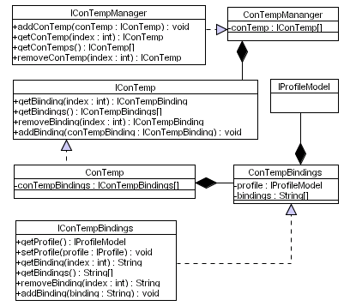
Figure 26 Context Template Manager

Issues
The issues associated with the Class Diagram are not known at this stage.

Requirements
Context templates must be used to guide dynamic service composition. Each context template used by the device must define a specific context in which the device and the services it provides can be used. The Context Template Manager must contain zero or more Context Templates and in turn each Context Template must contain one or more bindings. Each binding must contain a Service Profile Model and one or more service endpoints (bindings). Profile models are used to describe the type of services that are required before a device can be used in that context. For example a DVD Player that operates in the “Theatre” context must first discover devices capable of processing the video and audio streams. Only when such devices/services have been discovered can the context be realised. Each profile is extracted and used in a service request, which is propagated within the P2P network. All the responses received are added to the relevant Profile Model binding’s collection.

Assumptions
The framework does not place any constraints on how the objects are serialised, however the XML notation generated must be based on RDF(S) structures. This is left to the device manufacturer and the code to achieve this must be placed in the toString method.

Attributes
This Class Diagram supports several classes with each class containing zero or more attributes. Each of these attributes are listed and described below.
Class | Attribute | Description
ConTempManager | conTemp | This attribute collection contains all the context templates used by the device.
ConTemp | conTempBindings | This attribute contains all the context template bindings.
ConTempBindings | profile | This attribute collection contains all the profile models used within a specific context.
ConTempBindings | bindings | This attribute collection contains all the service endpoints/bindings for a particular profile model.
Table 49 Context Template Service Attributes

Methods
This Class Diagram supports several classes with each class containing zero or more methods. Each of these methods are listed and described below.
Class | Method | Description
IConTempManager | addConTemp | This method allows a context template to be added
IConTempManager | getConTemp | This method allows a specific context template to be retrieved.
IConTempManager | getConTemps | This method allows all the context templates to be retrieved.
IConTempManager | removeConTemp | This method allows a context template to be removed from the collection.
IConTemp | getBinding | This method allows a particular binding for a context to be retrieved.
IConTemp | removeBinding | This method allows a particular binding to be removed from the collection.
IConTemp | addBinding | This method allows a particular binding to be added to the collection.
IConTempBindings | getProfile | This method allows a profile model to be retrieved.
IConTempBindings | setProfile | This method allows a profile model to be assigned.
IConTempBindings | getBinding | This method allows a binding to be retrieved.
IConTempBindings | addBinding | This method allows a binding to be added to the collection.
IConTempBindings | removeBinding | This method allows a binding to be removed from the collection.
Table 50 Context Template Service Methods

Extensions
There are no known extensions for this Class Diagram at this stage of the design.

Class Diagram: Distributed Emergent Semantics (DistrES) Service

Description
This Class Diagram illustrates the classes required for implementing distributed emergent semantics within this framework. The Class Diagram is illustrated in Figure 27.
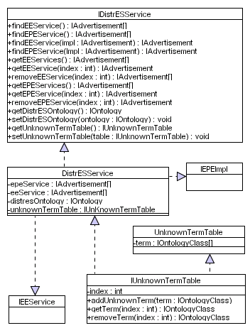
Figure 27 Distributed Emergent Semantics Service

Issues
The issues associated with the Class Diagram are not known at this stage.

Requirements
The DistrES service is a core service that must be implemented. Service requests and service descriptions are based on semantic structures. As such this service must be used as a semantic interoperability bridge between different vocabularies. This service comprises two other core services which are the Evolutionary Pattern Extraction Service and the Extraction Engine Service. These two services must be discovered before the DistrES service can be used. The DistrES Service also manages the DistrES Ontology. This ontology is the devices local knowledge base that contains concepts within a particular domain. For example a Speaker will contain concepts regarding speakers and how they may be used. Any terms that are not found must be added to the Unknown Term Table. The device will try to resolve these terms by discovering these concepts within the P2P network when the device is idle.

Assumptions
The assumptions for this Class Diagram are not known at this stage of the design.

Attributes
This Class Diagram supports several classes with each class containing zero or more attributes. Each of these attributes are listed and described below.
Class | Attribute | Description
DistrESService | epeService | This attribute contains a collection of EPE Service advertisements that are discovered.
DistrESService | eeService | This attribute contains a collection of EE Service advertisements that are discovered.
DistrESService | distresOntology | This attribute contains the devices local knowledge base that contains concepts within the devices domain.
DistrESService | unknownTermTable | This attribute is used to store unknown terms that could not be found in the devices knowledge base.
IUnknownTermTable | term | This attribute collection contains all the unknown terms.
Table 51 DistrES Service Attributes

Methods
This Class Diagram supports several classes with each class containing zero or more methods. Each of these methods are listed and described below.
Class | Method | Description
IDistrESService | findEEService | This method allows the Extraction Engine Service to be discovered. All the advertisements that are discovered are added to the eeService attribute collection.
IDistrESService | findEPEService | This method allows the Evolutionary Pattern Extraction Engine to be discovered. All the advertisements that are discovered are added to the epeService attribute collection.
IDistrESService | getEEService | This method allows an Extraction Engine Service advertisement to be retrieved.
IDistrESService | getEEServices | This method allows all the Extraction Engine Service advertisements to be retrieved.
IDistrESService | removeEEService | This method allows an Extraction Engine Service advertisement to be removed from the eeService collection.
IDistrESService | getEPEService | This method allows an Evolutionary Pattern Extraction Service advertisement to be retrieved.
IDistrESService | getEPEServices | This method allows all the Evolutionary Pattern Extraction Service advertisements to be retrieved.
IDistrESService | removeEPEService | This method allows an Evolutionary Pattern Extraction Service advertisement to be removed from the epeService collection.
IDistrESService | getDistrESOntology | This method allows the DistrES ontology to be retrieved.
IDistrESService | setDistrESOntology | This method allows the DistrES ontology to be assigned to the DistrES Service.
IDistrESService | getUnknownTermTable | This method allows the unknown term table to be retrieved.
IDistrESService | setUnknwonTermTable | This method allows the unknown term table to be assigned.
IUnknownTermTable | addUnknownTerm | This method allows a term to be added to the unknown term table.
IUnknownTermTable | getNextTerm | This method allows a term to be retrieved from the unknown term table.
IUnknownTermTable | removeTerm | This method allows a term to be removed from the unknown term table.
Table 52 DistrES Service Methods

Extensions
The DistrES Service uses an Unknown Term Table to store terms or relationships between terms that do not exist within the devices local knowledge base. Devices within the P2P network must continually evolve their local knowledge structures to ensure that it understands different vocabularies that enter the network. We envisage that the device will use the terms in the Unknown Term Table to periodically try and evolve its internal knowledge structures by asking other devices within the network if they have a concept that relates to the term. This process may occur when the device is idle. However it may also be possible to perform this process in real-time instead of using the Unknown Term table – as soon an unknown term is found it will be propagated within the network and the device will attempt to evolve its internal knowledge structures if any results are returned. This process may however be time and process intensive, which may result in a poor quality of service. This area needs further consideration.

Class Diagram: Extraction Engine Service

Description
This Class Diagram illustrates the classes required for the extracting concepts from the knowledge base within this framework. The Class Diagram is illustrated in Figure 28.
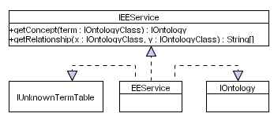
Figure 28 Extraction Engine Service

Issues
The issues associated with the Class Diagram are not known at this stage.

Requirements
The Extraction Engine service allows concepts to be extracted from the devices knowledge base. This service must allow concepts to be extracted and allow the relationships between terms to be extracted. If a concept cannot be extracted or a relationship been two terms cannot be established all the unknown terms must be added to the Unknown Term Table. The device will use this table to periodically try and discover these concepts within the P2P network when the device is in an idle state.

Assumptions
The framework does not place any constraints on how the objects are serialised, however the XML notation generated must be based on RDF(S) structures. This is left to the device manufacturer and the code to achieve this must be placed in the toString method.

Attributes
This Class Diagram supports several classes with each class containing zero or more attributes. Each of these attributes are listed and described below.
Class | Attribute | Description
N/A | N/A | N/A
Table 53 Extraction Engine Service Attributes

Methods
This Class Diagram supports several classes with each class containing zero or more methods. Each of these methods are listed and described below.
Class | Method | Description
IEEService | getConcept | This method allows a concept to be retrieved from the DistrES ontology.
IEEService | getRelationship | This method allows a relationship(s) between two terms to be retrieved from the DistrES ontology.
Table 54 Extraction Engine Service Methods

Extensions
There are no known extensions for this Class Diagram at this stage of the design.

Class Diagram: Evolutionary Pattern Extraction Engine Service

Description
This Class Diagram illustrates the classes required to extract common patterns and evolve knowledge structures within this framework. The Class Diagram is illustrated in Figure 29.
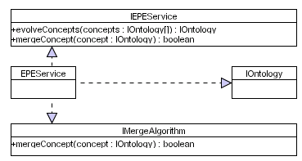
Figure 29 Evolutionary Pattern Extraction Engine Service

Issues
The issues associated with the Class Diagram are not known at this stage.

Requirements
The Evolutionary Pattern Extraction Service evolves knowledge structures using general consensus. The device will use this service to evolve its knowledge base over time and evolve the concepts returned from propagating unknown terms within the P2P network. This service accepts several knowledge structures and using general consensus it must produce an optimal knowledge structure that captures the generally agreed terms and relationships that exist. When an optimal structure has bee evolved it must be merged into the devices current knowledge base.

Assumptions
The framework does not place any constraints on how the objects are serialised, however the XML notation generated must be based on RDF(S) structures. This is left to the device manufacturer and the code to achieve this must be placed in the toString method.

Attributes
This Class Diagram supports several classes with each class containing zero or more attributes. Each of these attributes are listed and described below.
Class | Attribute | Description
N/A | N/A | N/A
Table 55 EPE Service Attributes

Methods
This Class Diagram supports several classes with each class containing zero or more methods. Each of these methods are listed and described below.
Class | Method | Description
IEPEService | evolveConcepts | This method allows a number of ontological structures to be evolved to produce an optimal structure that captures the general consensus.
IEPEService | mergeConcept | This method allows an ontological structure to be merged into the devices current knowledge base.
IMergeAlgorithm | mergeConcept | This method allows an ontological structure to be merged into the devices current knowledge base.
Table 56 EPE Service Methods

Extensions
There are no known extensions for this Class Diagram at this stage of the design.

Class Diagram: DistrES Ontology

Description
This Class Diagram illustrates the classes required to describe ontologies within this framework. The Class Diagram is illustrated in Figure 30.
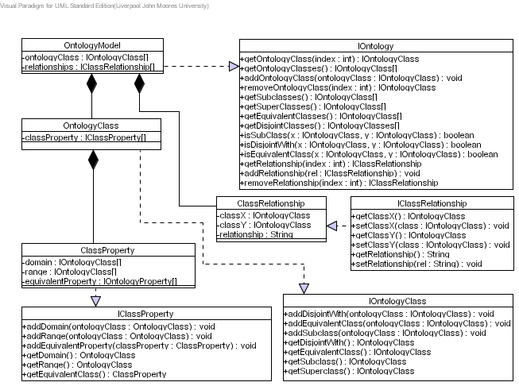
Figure 30 DistrES Ontology

Issues
The issues associated with the Class Diagram are not known at this stage.

Requirements
The DistrES Ontology captures all the classes within a knowledge structure, the properties it supports and the relationships it has with other classes. The Ontology Model must contain zero or more ontology classes and in turn the ontology class must have zero or more properties. Each property must belong to a particular domain and the values it supports must be within a specified range. The model must be used to determine what classes exist, what properties exist and to which class they belong and what relationships between classes exist. This model must describe the devices domain knowledge and contain semantic information that bridges the gap between terms that are semantically equivalent but syntactically distinct.

Assumptions
The framework does not place any constraints on how the objects are serialised, however the XML notation generated must be based on RDF(S) structures. This is left to the device manufacturer and the code to achieve this must be placed in the toString method.

Attributes
This Class Diagram supports several classes with each class containing zero or more attributes. Each of these attributes are listed and described below.
Class | Attribute | Description
OntologyModel | ontologyClass | This attribute contains a collection of classes contain in the ontology model
OntologyModel | relationships | This attribute contains a collection of relationships that exist between the classes in the ontology model.
OntologyClass | classProperty | This attribute contains a collection of properties associated with a particular class.
ClassProperty | domain | This attribute collection contains the domain in which the property exists.
ClassProperty | range | This attribute collection contains the range of values the property is allowed to have.
ClassProperty | equivalentProperty | This property contains a collection of properties that are equivalent to the current property.
Table 57 DistrES Ontology Attributes

Methods
This Class Diagram supports several classes with each class containing zero or more methods. Each of these methods are listed and described below.
Class | Method | Description
IOntology | getOntologyClass | This method allows a specific class to be retrieved from the ontology model
IOntology | getOntologyClasses | This method allows all the classes to be retrieved from the ontology model.
IOntology | addOntologyClass | This method allows a class to be added to the ontology model.
IOntology | removeOntologyClass | This method allows a class to be removed from the ontology class.
IOntology | getSubclasses | This method allows the subclasses within the ontology model to be retrieved.
IOntology | getSuperclasses | This method allows the superclasses within the ontology model to be retrieved.
IOntology | getEquivalentClasses | This method allows the equivalent classes within the ontology model to be retrieved.
IOntology | getDisjointClasses | This method allows the disjoint class within the ontology model to be retrieved.
IOntology | isSubClass | This method checks to see if a subclass relationship exists between two terms.
IOntology | isDisjointWith | This method checks to see if a disjoint with relationship exists between two terms.
IOntology | isEquivalentClass | This method checks to see if an equivalent class relationship exists between two terms.
Table 58 DistrES Ontology Methods

Extensions
There are no known extensions for this Class Diagram at this stage of the design.

Class Diagram: Semantic Interoperability and Signature Matching (SISM) Service

Description
This Class Diagram illustrates the required classes for performing semantic interoperability. The Class Diagram is illustrated in Figure 31.
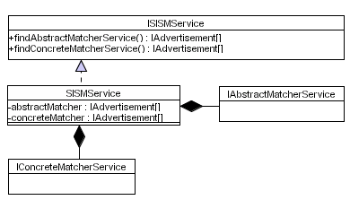
Figure 31 Semantic Interoperability and Signature Matching Service

Issues
The issues associated with the Class Diagram are not known at this stage.

Requirements
The SISM service is responsible for semantically matching service requests with service descriptions using capability and signature matching. This service must begin by abstract matching a service request with each of the services the device provides. Any services that are matched at the abstract level must be matched at a concrete level to determine if the IOPEs described in the service request can be matched with concrete signatures defined in the service interface. In the framework the concrete matching stage is optional if dynamic service composition is not being used. In this instance the abstract matching algorithm will match service descriptions based on their capabilities – for each match found the service advertisement must be returned to the service requester. The concrete matching algorithm must also try and resolve data type conflicts that occur by discovering intermediary services that can adapt conflicting data into the required data.

Assumptions
The framework does not place any constraints on how service requests and service descriptions are serialised, however the XML must be based on RDF(S) structures – this decision is left to the device manufacturer.

Attributes
This Class Diagram supports several classes with each class containing zero or more attributes. Each of these attributes are listed and described below.
Class | Attribute | Description
SISMService | abstractMatcher | This attribute contains a collection of Abstract Matcher service advertisements.
SISMService | concreteMatcher | This attribute contains a collection of Concrete Matcher service advertisements.
Table 59 SISM Service Attributes

Methods
This Class Diagram supports several classes with each class containing zero or more methods. Each of these methods are listed and described below.
Class | Method | Description
ISISMService | findAbstractMatcherService | This method allows Abstract Matcher services to be discovered locally and remotely within the P2P network.
ISISMService | findConcreteMatcherService | This method allows Concrete Matcher services to be discovered locally and remotely within the P2P network.
Table 60 SISM Service Methods

Extensions
There are no known extensions for this Class Diagram at this stage of the design.

Class Diagram: Abstract Matcher Service

Description
This Class Diagram illustrates the classes required to abstract match service requests with service descriptions. The Class Diagram is illustrated in Figure 32.
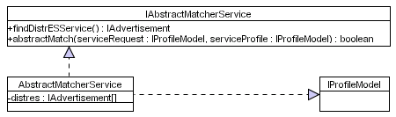
Figure 32 Abstract Matcher Service

Issues
The issues associated with the Class Diagram are not known at this stage.

Requirements
The Abstract Matcher service must match a service request with service description. A service request must be used that conforms to a Service Profile Model, which describes the capabilities of a candidate service in terms of its capabilities. This is achieved by describing IOPEs. The Abstract Matcher service must compare the IOPEs in the service request with IOPEs in the service description. There will inherently be terminology and categorisation differences, consequently the Abstract Matching service must use the DistrES service to resolve any conflicts that may occur.

Assumptions
The framework does not place any constraints on how service requests and service descriptions are serialised, however the XML must be based on RDF(S) structures – this decision is left to the device manufacturer.

Attributes
This Class Diagram supports several classes with each class containing zero or more attributes. Each of these attributes are listed and described below.
Class | Attribute | Description
AbstractMatcherService | distress | This attribute contains a collection of DistrES advertisements.
Table 61 Abstract Matcher Service Attributes

Methods
This Class Diagram supports several classes with each class containing zero or more methods. Each of these methods are listed and described below.
Class | Method | Description
IAbstractMatcherService | findDistrESService | This method allows DistrES services to be discovered locally and remotely within the P2P network.
IAbstractMatcherService | abstractMatch | This method performs an abstract match between a service request and a service description.
Table 62 Abstract Matcher Service Methods

Extensions
There are no known extensions for this Class Diagram at this stage of the design.

Class Diagram: Concrete Matcher Service

Description
This Class Diagram illustrates the required classes to concrete match service descriptions with signatures in service interfaces. The Class Diagram is illustrated in Figure 33.
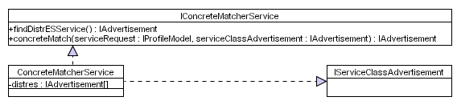
Figure 33 Concrete Matcher Service

Issues
The issues associated with the Class Diagram are not known at this stage.

Requirements
The Concrete Matcher Service is responsible for matching the IOPEs in the service request with concrete bindings in the service interface. The IOPEs in the service request must be mapped onto IOPEs in the Service Profile. If a match is found the matching IOPEs must be mapped onto a single Atomic Process in the Service Process Model and the Atomic Process must be mapped onto an Atomic Process in the Service Grounding. Once this mapping has been successfully achieved the data type information for each IOPE must be compared with parameters in a signature described in the service interface. If no data type conflicts occur then this is classed as a concrete match. If conflicts are discovered then they must be resolved using intermediary services.

Assumptions
The framework does not place any constraints on how service requests and service descriptions are serialised, however the XML must be based on RDF(S) structures – this decision is left to the device manufacturer.

Attributes
This Class Diagram supports several classes with each class containing zero or more attributes. Each of these attributes are listed and described below.
Class | Attribute | Description
ConcreteMatcherService | distress | This attribute contains a collection of DistrES advertisements.
Table 63 Concrete Matcher Service Attributes

Methods
This Class Diagram supports several classes with each class containing zero or more methods. Each of these methods are listed and described below.
Class | Method | Description
IConcreteMatcherService | findDistrESService | This method allows DistrES services to be discovered locally and remotely within the P2P network.
IConcreteMatcherService | concreteMatch | This method performs a concrete match between a service request and a service description.
Table 64 Concrete Matcher Service Methods

Extensions
There are no known extensions for this Class Diagram at this stage of the design.

Class Diagram: Security Manager

Description
This Class Diagram illustrates the required classes to implement security within this framework. The Class Diagram is illustrated in Figure 33.
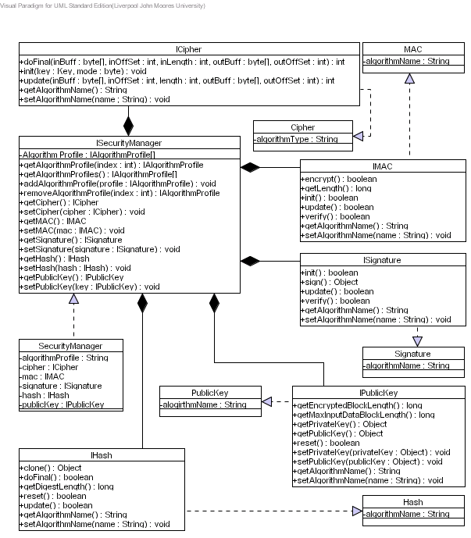
Figure 34 Security Manager

Issues
The issues associated with the Class Diagram are not known at this stage.

Requirements
Need to do

Assumptions
Need to do

Attributes
This Class Diagram supports several classes with each class containing zero or more attributes. Each of these attributes are listed and described below.
Class | Attribute | Description
Cipher  MAC  Signature  PublicKey  Hash | algorithmName | This attribute contains the name of the algorithm being used for the Cipher, MAC, Signature, PublicKey and Hash.
SecurityManager | algorithmProfile | This attribute contains algorithm profiles, which specifies what combination of algorithms must be used. In this instance a profile will specify the algorithm that must be used for encryption and the algorithm that must be used hashing.
SecurityManager | cipher | This attribute contains the cipher algorithm used to encrypt and decrypt data. The cipher algorithm may be based on symmetric or asymmetric ciphers (one key used to encrypt and decrypt or different keys used to encrypt or decrypt).
SecurityManager | mac | This attribute contains the Message Authentication Code (MAC) algorithm, i.e. MD5 or SHA1, which is used to generate a small block of data, which is generated by applying a secret key to the message. MACs are used to authenticate messages using symmetric key encryption.
SecurityManager | signature | This attribute contains the Signature algorithm which is used to generate public/private key pairs. Digital signatures are used for asynchronous encryption.
SecurityManager | hash | This attribute contains the hashing algorithm used. The hashing algorithm is used to compact data so that it is verifiable but it must be impossible to reconstruct the original message by using the same value for the hashing process.
SecurityManager | publicKey | This attribute contains the Public Key algorithm used.
Table 65 Security Manager Attributes

Methods
This Class Diagram supports several classes with each class containing zero or more methods. Each of these methods are listed and described below.
Class | Method | Description
ICipher | doFinal | This method encrypts data in a single part operation or in the last part of a multi-part operation.
ICipher | init | This method allows the cipher to be initialised with the public key retrieved from a particular certificate.
ICipher | update | This method allows a multi-part encryption/decryption operation to continue.
ICipher  IMAC  ISignature  IHash  IPublicKey | getAlgorithmName | This method allows the name of the algorithm to be retrieved. The name usually corresponds to the type of algorithm being used.
ICipher  IMAC  ISignature  IHash  IPublicKey | setAlgorithmName | This method allows the name of the algorithm to be set. The name usually corresponds to the type of algorithm being used.
ISecurityManager | getAlgorithProfile | This method allows the algorithm profile to be retrieved. An algorithm profile can be a combination of public key, hashing and cipher algorithms, i.e. PublicKey_Hash, Cipher_Hash or PublicKey_Cipher_Hash.
ISecurityManager | getAlgorithmProfiles | This method allows all the supported algorithm profiles to be retrieved.
ISecurityManager | addAlgorithmProfile | This method allows an algorithm profile to be added to the algorithmProfile attribute collection.
ISecurityManager | removeAlgorithmProfile | This method allows an algorithm profile to be removed from the algorithm profile attribute.
ISecurityManager | getCipher | This method allows the cipher algorithm to be retrieved.
ISecurityManager | setCipher | This method allows the cipher algorithm to be set.
ISecurityManager | getMAC | This method allows the MAC algorithm to be retrieved.
ISecurityManager | setMAC | This method allows the MAC algorithm to be set.
ISecurityManager | getSignature | This method allows the Signature algorithm to be retrieved.
ISecurityManager | setSignature | This method allows the signature algorithm to be set.
ISecurityManager | getHash | This method allows the Hash algorithm to be retrieved.
ISecurityManager | setHash | This method allows the Hash algorithm to be set.
ISecurityManager | getPublicKey | This method allows the Public Key algorithm to be retrieved.
ISecurityManager | setPublicKey | This method allows the Public Key algorithm to be set.
IMAC | encrypt | This method allows the data to be encrypted.
IMAC | getLength | This method returns the byte length of the data
IMAC | init | This method allows any required MAC initialisation.
IMAC | update | This method allows the data to be encrypted to be updated.
IMAC | verify | No sure what this does yet
ISignature | init | This method allows any required Signature initialisation.
ISignature | sign | This method allows the encrypted data to be signed.
ISignature | update | This method allows the signed data to be signed.
ISignature | verify | The method allows the signature to be verified after the updating has been complete.
IHash | clone | This method allows the Hash object to be cloned.
IHash | doFinal | This method is called when the final piece of data is being processed.
IHash | getDigestLength | This method returns the length of the digest.
IHash | reset | This method resets the hash.
IHash | update | This method is called if all data cannot be put into a single byte array.
IPublicKey | getEncryptedBlockLength | This method gets the length of the encrypted block.
IPublicKey | getMaxInputDataBlockLength | This method gets the maximum data block length.
IPublicKey | getPrivateKey | The method returns a private key.
IPublicKey | getPublicKey | This method returns a public key.
IPublicKey | reset | This method resets the public key algorithm.
IPublicKey | setPrivateKey | This method sets the private key.
IPublicKey | setPublicKey | This method sets the public key.
Table 66 Security Manager Methods

Extensions
There are no known extensions for this Class Diagram at this stage of the design.

References

